CONTENTS PAGE

Preface from Chief Officers | Page 1
Introduction | Page 2
NA CPC ‘Our Vision’ | Page 3
Strategic Links | Page 4
Improving Outcomes | Page 5
Self - Evaluation | Page 8
Annual Statistical Report | Page 10
Significant Case Review | Page 20
North Ayrshire Child & Public Protection Chief Officer Group | Page 22
Fulfilling the NACPC Functions – Progress | Page 23
Financial Report | Page 31
Group Membership  Action Plan Progress 2018/2019 | Page 32  Page 48

Preface from Chief Officers

The Child and Public Protection Chief Officers are very pleased to present the 2018 - 2019 Annual Report for North Ayrshire Child Protection Committee.

In 2018 and 2019, North Ayrshire Child Protection Committee has experienced both challenges and developments. This has included high child protection activity, the initiation of a Significant Case Review and the launch of the 13 Ways Suicide Prevention Campaign for young people. 2019 and 2020 will focus on cultural change and building on the 13 Ways Campaign and other suicide prevention activity to promote young people’s mental health. A continued focus to work in partnership with young people in taking forward child protection improvements will also remain a priority. North Ayrshire remains committed to the focused drive to protect children and young people from harm, and a newly developed emphasis on outcomes will ensure that there is meaningful monitoring and scrutiny of the ways in which we are addressing the protection of children in North Ayrshire and making a meaningful impact.

This report outlines the main aspects of the work undertaken by North Ayrshire Child Protection Committee and we hope that this provides an insight into the Committee’s delivery of its core business over the past year.

Anne Houston  Chair  Child Protection Committee | Craig Hatton  Chief Executive  North Ayrshire Council | John Burns  Chief Executive  NHS Ayrshire & Arran | Mark Hargreaves  Divisional Commander  Police Scotland “U” Division

Introduction

2018 and 2019 has been a time of significant change for North Ayrshire Child Protection Committee; staff changes, the initiation of a Significant Case Review and high levels of child protection activity across all services. A re-directed focus on outcomes within the Child Protection Business Plan has supported a year of development and has seen the beginning of a cultural shift for multi-agency staff managing child protection.

During late 2018, the committee staff team changed significantly with a new CPC Learning and Development Co-ordinator and two new Senior Clerical Assistants. This has presented challenges due to periods of learning and embedding for the new staff; but has also supported innovation and creativity in relation to ways of working and harnessing the best methods of getting child protection messages to both workers and communities within North Ayrshire.

The Child Protection Committee conducted one Initial Case Review (ICR) in 2018, and the ICR panel agreed that this would proceed to a Significant Case Review (SCR). From the ICR, it was apparent that recurring themes from North Ayrshire’s first SCR in 2016 are still present in some multi agency working. These include lack of clarity and ownership of multi-agency communication and follow through, over-ready acceptance of apparent positive changes in attitude and/or behaviour of parents/carers and children’s experiences not being sufficiently taken account of due to the privileging of adult’s voices and views. The panel agreed that the SCR requires a bespoke methodology which will target a multi-agency cultural shift. The SCR will progress in 2019/2020, and it is expected that this will evoke change in how agencies work together to ensure that children are safe from harm.

In last year’s annual report, data had started to indicate record high levels of child protection activity across North Ayrshire. This has continued into 2019. This is understood in the context of the establishment of a specific Child Protection Team who have improved response rates. Although data indicates improvements, the committee remain aware of the necessity to continuously monitor, review and analyse the data while acknowledging the impact that this has on resources.

The focus and reporting mechanisms for the CPC business plan has also changed for 2019/2020. The CPC will focus more clearly on outcomes and the child protection activity implemented to positively influence outcomes will be reported via the Evaluation and Improvement sub-group. The shift in focus to outcome monitoring will ensure that Committee members are assessing the impact of actions and how this makes a difference to children and young people – the answer to the ‘so what’ question we must always ask ourselves to ensure that changes we make are having the desired result

North Ayrshire Child Protection Committee - Our Vision

The North Ayrshire Child Protection Committee annual report reflects on key achievements over the last year in pursuit of our vision for children: A Better Childhood
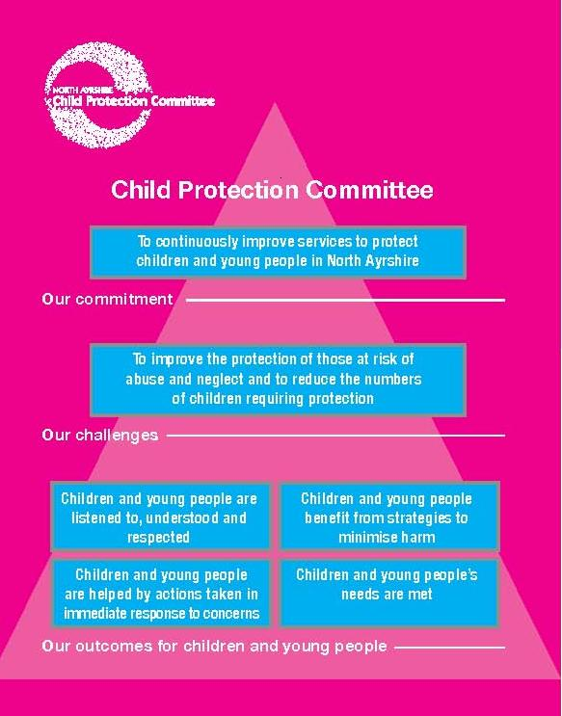
Strategic Links

Community Planning Partnership

Child & Public Protection Chief Officers Group
(Child Protection, Adult Support & Protection, MAPPA)

NA CPC SUB GROUPS
Violence Against Women Partnership (VAWP)
Adult Protection Committee
(APC)
Alcohol & Drug Partnership
(ADP)

CAPSM Sub Group
(Joint sub group with ADP)

Child Protection Committee

Children’s Services Public Protection

Children’s Services Strategic Partnership

Public Information & Engagement Sub Group

Learning & Development
Sub Group

Management Information
Sub Group

Evaluation and Improvement Sub Group

Short Life Working Groups

Improving Outcomes

National Outcome | We have improved the life chances of children, young people and families at risk
Intermediate Outcome 1 | Children & young people are listened to, understood and respected.
Key activity this year to support this outcome: | North Ayrshire CPC initiated a Short Life Working group to take forward a qualitative piece of work on children’s experiences of child protection processes. Eight young people were asked in some detail about their experiences, with the support of the Rosemount Project and the Children 1st child protection advocacy support service. A report was completed which described the feedback collated from the young people and concluded with the following findings: child protection processes within North Ayrshire require to be considered and reviewed from the perspective of the children involved; an interactive resource which supports children’s understanding of child protection processes should be developed; there should be a routine question in paperwork which asks if young people had the opportunity to meet with a senior officer at the earliest stage before the initial case conference, the feedback will help shape advocacy support going forward; and that the continued funding of Kinship Care arrangements for children on the Child Protection Register require to be reinstated if the child remains in the Kinship Care arrangement.  Kinship funding arrangements for children on the Child Protection Register are already in the process of being reviewed and updated.
Priority action next year: | North Ayrshire Child Protection Committee will direct workstreams in response to the findings of the evaluation work in the coming year.
Intermediate Outcome 2 | Children and young people benefit from strategies to minimise harm
Key activity to support this outcome: | The Young People’s (YP) Suicide Taskforce (formerly the Young People’s Operational Suicide Prevention Group) has continued to meet regularly, with governance from the Young People’s Strategic Suicide Prevention Group (YPSSPG). Over the course of a year the YP Taskforce has progressed work in two community action plans with the overall objective of preventing suicide in young people. A key element of the community action plan has been the 13 Ways Campaign. A series of 13 animations with key messages focusing on young people supporting each other, were developed and released via social media in the weeks leading up to Xmas 2018 – starting in September coinciding with Suicide Prevention Week ( 10th September 2018). The animations illustrated one of each of 13 messages, with a narration by a young person and an animation to illustrate the message. There was also an introductory message and a final adult message which was added in towards the end from the parents of one of the young people who had died within North Ayrshire. The key message is that suicide is not the solution – there are many people and ways to support and help. Young people were central to developing the language, visuals and stories, and were supported to contribute meaningfully specifically (but not exclusively) through the Year of the Young People Ambassadors. The campaign has been very well received and has been given a positive response perhaps because of the ownership by all groups and the young people of the messages and the rationale. Young people have been the best ambassadors – the YOYP ambassadors winning the category prize for Mental Health and Wellbeing in the Youth Link awards for this work.
Priority action next year: | The YPSSPG and Young People’s Suicide Taskforce are committed to building on the 13 Ways Campaign and maximising the reach of the campaign to young people. Key activity over the coming year will include peer research with the aim of developing a mental health toolkit, getting celebrity endorsement to widen the reach of the 13 Ways social media campaign and working with young people to agree a message in relation to supporting their peers when they have concerns that a friend has suicidal intent.
Intermediate Outcome 3 | Children and young people are helped by actions taken in immediate response to concerns
Key activity to support this outcome: | The YPSSPG finalised a Crisis Response Plan in the event of a young person completing suicide. A Table Top exercise was co-ordinated by the CPC and Police Scotland in September 2018 to test the plan, the exercise evaluated well and provided multi-agency workers with the opportunity to discuss how they could work and support each other in the event of a completed suicide by a young person. Unfortunately, the plan was initiated on a number of occasions in 2018/2019 due to young people completing suicide. Each death had a profound impact on the families, communities and workers who knew the young person; but it was agreed by both the Young People’s Suicide Taskforce and the YPSSPG that the plan was effective in protecting and supporting young people whom were impacted by the deaths.  The CPC also commissioned a short life working group to establish guidance in relation to suicide risk assessment and safe planning within education. This will ensure that young people are receiving a consistent and efficient response from all members of education staff when there are concerns in relation to their mental health and wellbeing. At the time of writing this report the guidance is in the process of being finalised with a planned launch in September 2019.  A short life working group has been convened in collaboration with North Ayrshire Adult Support and Protection Committee to take forward the National Missing Person’s Framework within North Ayrshire.
Priority action next year: | The CPC has identified that Leadership is a priority to ensure that workers are empowered and supported to protect children and young people. A child protection multi-agency leadership competency framework will be developed for workers within the HSCP, education and Police Scotland. We will support the implementation and delivery of reflective supervision practices across all services to ensure that staff are receiving the necessary guidance and direction to meet children’s wellbeing needs and that they are protected from harm.  The National Missing Person’s Short Life Working Group will take forward the Framework within North Ayrshire, and return discussion national best practice will be taken forward through learning and development opportunities for staff.
Intermediate Outcome 4 | Children and young people’s needs are met
Key activity to support this outcome: | A Short Life Working Group has been convened to develop a Child Sexual Abuse (CSA) strategy within North Ayrshire and to make recommendations as to how this will be implemented, including identifying how Stop to Listen is taken forward in North Ayrshire and ensuring that there is an informed working position response to Child Sexual Exploitation.  2018/2019 has seen record high levels of child protection activity within North Ayrshire. In 2017 and a dedicated child protection social work team was established. Since the formation of the team, there has been a noted increase in the number of child protection referrals, child protection investigations and the number of children being placed on the child protection register. This has resulted in more at risk children being identified at an earlier stage. There are indications that this is already having an impact as increasing numbers of children are deregistered within 12 months because of improved home circumstances rather than requiring to be accommodated, as happened more frequently in the past.
Priority action next year: | The CPC business plan for 2019/2020 has a renewed focus on outcomes and outputs rather than activities and tasks. This focus will ensure that the Child Protection Committee are monitoring and measuring the impact that child protection work is having on meeting the needs of children and young people, and whether different approaches are required to meet the outcomes and outputs.

Self - Evaluation

As discussed previously, the CPC took forward a qualitative piece of evaluation work on children’s experiences of child protection processes. This was led by a short life working group from the Evaluation and Improvement sub-group and was heavily supported by Children 1st and the Rosemount project. The objective of this work was to identify changes the CPC could potentially make to support better participation and engagement and ultimately improve the experiences of children and young people involved in the child protection process. Five significant recommendations were made as a result and all were agreed to be actioned as part of the 2019/2020 CPC business plan. A theme which clearly ran through this evaluation was the importance of people with whom a child or young person has a positive supportive relationship being available at each stage of the journey. This is the major help to them being able to engage, ask questions, promote their understanding and be supported emotionally.

The CPC also co-ordinated quality assurance on Joint Investigative Interviews (JII) in collaboration with the West of Scotland JII co-ordinator, social work and the police. There were both areas of strength and concern that were raised during this process, and the findings will be used to identify further training needs for staff who facilitate JIIs. It has also been identified that in the vast majority of interviews, police officers will take the lead in interviewing, which means that social workers are not getting the opportunity to use their knowledge and skills they have learned from JII training. This has identified a necessity for a cultural shift on taking responsibility for the lead in JIIs (which is also an issue for other areas nationally within Scotland). At the time of writing the report, North Ayrshire has applied to be a pilot for the introduction of the new national JII training in collaboration with East and South Ayrshire. The CPC would welcome the learning opportunity that this would bring to staff within North Ayrshire.

AYRshare chronologies are being audited by social work and the GIRFEC manager, this is being reported into each quarterly CPC and features in the 2019/2020 business plan.

Audit themes for 2019/2020 will include an evaluation on Child Protection Orders (CPO), which will examine the timeliness of the measure and whether there were opportunities for earlier intervention, prior to the Order being issued. This is in response to a recent increase in the number of CPOs being issued within North Ayrshire. There will be a follow up audit to identify the impact of changes made on Child Protection Case Conference and Core Group minutes which was previously undertaken in February 2018.

PRISM - Practice Reflection and Improvement Short Modules

A further PRISM session was delivered to multi-agency staff in 2018, and two further bespoke sessions were delivered to education child co-ordinators. These sessions provided a space for workers to reflect on the story of the Significant Case Review of J family and gain insight into the children’s experiences. This supported workers to explore the importance of communication and collaboration when there are wellbeing and child protection concerns, and how over privileging of adult’s views can lead to the diminishment of children’s experiences. Feedback from these sessions were overwhelmingly positive, and next year there will be further PRISM sessions with a focus on the evaluation work that was completed on children’s experiences of the child protection system. Evaluation feedback will establish the long term impact of the PRISM sessions and the value that these have for workers when managing future child protection issues.

Annual Statistical Report

This section contains key data for the period 1st August 2018 to 31st July 2019, with national comparison where this is available.

Chart 1: Number of concerns about children which are shared with the Health and Social Care Partnership

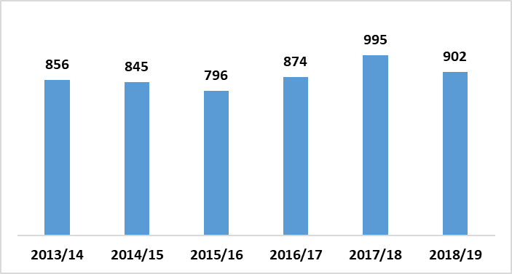

The 902 Child Protection concerns received this year represents a 9% drop compared to last year, however this is still higher than in any year previous to last year.

Chart 2: Number and outcome of Child Protection Investigations completed

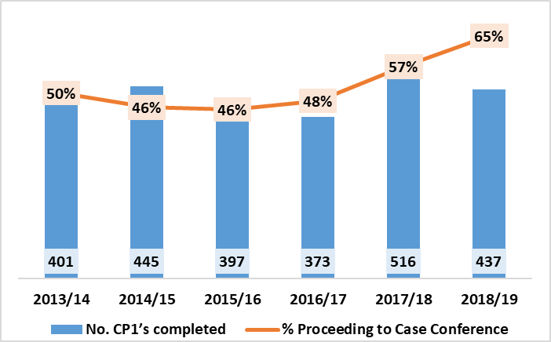

There were 437 Child Protection Investigations (CP1s) completed in 2018/19 – 15% less than last year. The proportion of CP1s which progressed to case conference increased to 65% - a higher proportion than in any of the last 6 years.

Chart 3: Number of Case Conferences and percentage of children who are placed on the register from a conference

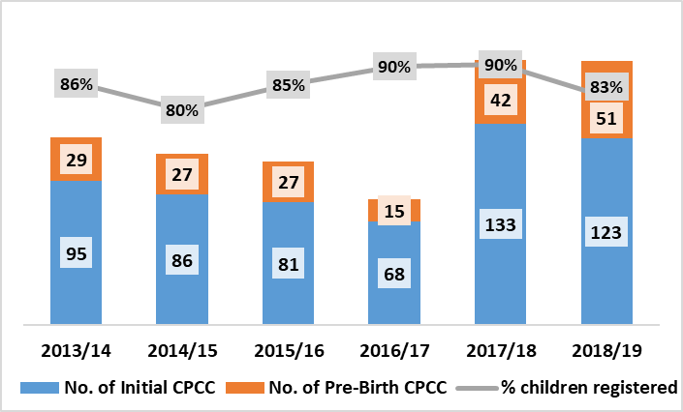

After 2017/18 saw the highest number of initial case conferences and the highest number of pre-birth case conferences in the last 6 years, 2018/19 has seen a slight drop in the number of initial Child Protection Case Conferences, although it remains much higher than in years previous to 2017/18. The number of pre-birth case conferences increased again this year and is higher than in any previous year. As the grey line in the chart shows, 83% of children who had a conference were then placed on the register, which is a drop from 90% last year and lower than in any of the last 3 years.

Chart 4: Number of registrations to and de-registrations from Child Protection Register

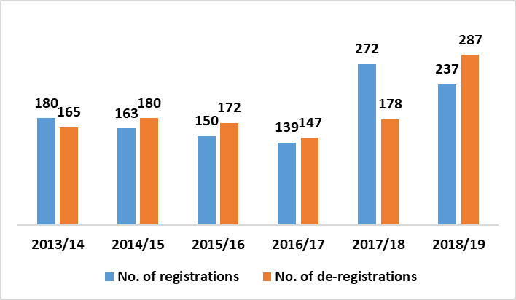

There were 237 Child Protection registrations in 2018/19, and 287 de-registrations. The number of registrations decreased compared to last year but remains significantly higher than in years previous to 2017/18. The number of de-registrations significantly increased and was much higher this year than in any of the previous six years. This is possibly due to a significant increase in registrations the previous year.

Chart 5: Length of registration at time of de-registration

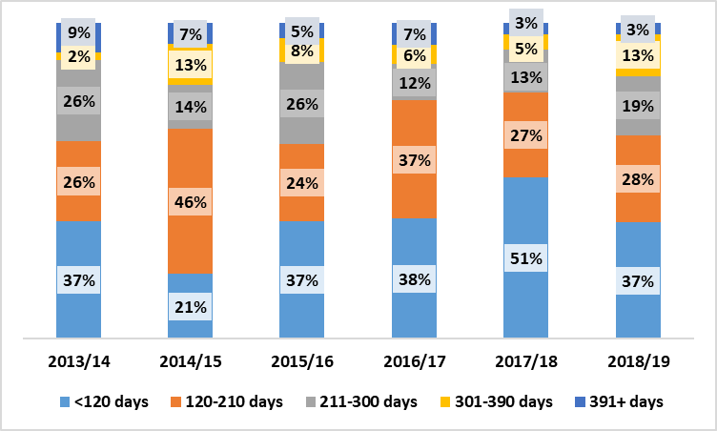

In 2018/19, over one third of children de-registered from the Child Protection register had been registered for less than 120 days – meaning they were most likely de-registered at the first conference following the registration. This was a drop compared to last year where over half were de-registered at this point. The majority of children were registered for more than 120 days; it can take some time to sustain reduced risk to children on the register prior to de-registration. 16% of cases were de-registered following a registration period of over 300 days (around 10 months).

Chart 6: Reason for de-registration

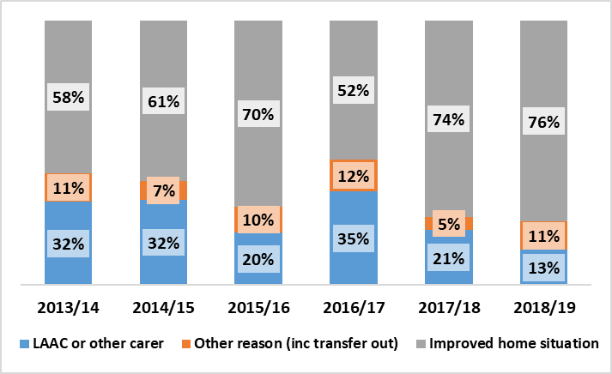

The proportion of cases de-registered due to improved home situation continued to rise this year and this year saw the highest proportion of de-registrations due to improved home situations in the last 6 years – 76% of de-registrations in 2018/19 were for this reason. This year also saw the smallest proportion of cases of children being de-registered due to becoming accommodated in any of the previous 6 years.

Chart 7: Child Protection Timescales

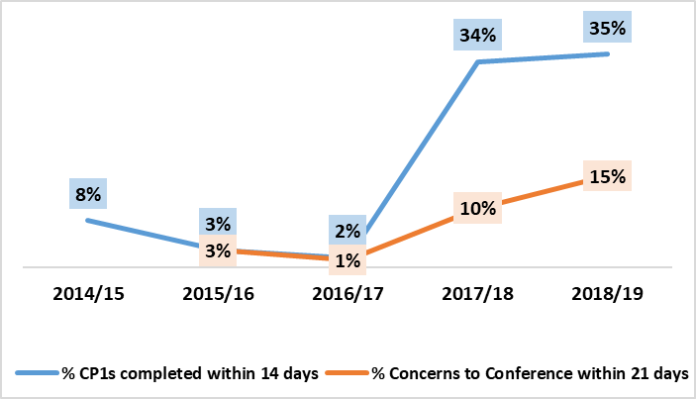

We can see in 2018/19 there was continued improvement in performance against Child Protection timescales. The percentage of Child Protection investigations completed within 14 days of the notification of concern increased slightly, from 34% last year to 35%, while the percentage of case conferences which occurred within 21 days of the notification of concern increased from 10% to 15%. It should also be noted that many cases which did not meet the 21 day target in 2018/19 occurred just outside the 21 days. This is an area of continued focus, however timescales have been raised nationally via Child Protection Committees Scotland for further review within the National Guidance for Child Protection in Scotland.

Table 1: Rate per 1,000 of children referred to reporter on offence and non-offence grounds

 | North Ayrshire |  | Dundee |  | East Ayrshire |  | Inverclyde |  | West Dunbartonshire |  | Scotland
 | Offence | Non-Off | Offence | Non-Off | Offence | Non-Off | Offence | Non-Off | Offence | Non-Off | Offence | Non-Off
2012/13 | 11.4 | 53.2 | 8.2 | 13.3 | 10.9 | 54.7 | 6.6 | 31.9 | 9.6 | 42.4 | 7.7 | 22.2
2013/14 | 7.0 | 47.8 | 6.4 | 12.3 | 6.1 | 38.4 | 5.1 | 31.8 | 6.9 | 39.9 | 6.2 | 19.2
2014/15 | 8.1 | 41.0 | 7.1 | 15.2 | 7.4 | 26.1 | 5.9 | 33.1 | 6.5 | 23.4 | 6.5 | 15.5
2015/16 | 9.9 | 54.4 | 8.6 | 13.7 | 9.6 | 38.1 | 6.0 | 29.0 | 5.4 | 18.7 | 6.2 | 15.0
2016/17 | 8.2 | 30.1 | 8.7 | 10.4 | 7.1 | 26.0 | 7.3 | 33.3 | 6.3 | 20.2 | 6.7 | 14.5
2017/18 | 7.2 | 28.4 | 8.3 | 8.5 | 6.8 | 23.7 | 6.3 | 26.5 | 9.0 | 16.7 | 6.7 | 12.3
2018/19 | 7.4 | 28.1 | 7.1 | 9.3 | 5.4 | 23.4 | 6.8 | 23.4 | 8.9 | 14.6 | 6.1 | 11.8

The above table shows the annual rate (per 1000 of children aged 8-16 (offence) and under 16 (non-offence)) of children referred to the reporter each financial year from 2012/13 and shows North Ayrshire and 4 comparator authorities identified by the head of service. There has been a generally decreasing trend of children referred to the reporter in North Ayrshire. The rate of children referred on offence grounds this year increased slightly while non-offence grounds decreased slightly this year compared to last. In 2018/19 North Ayrshire had a lower rate of offence referrals than West Dunbartonshire, but the highest rate of non-offence referrals amongst the comparator authorities.

Table 2: Rate per 1,000 of children on Compulsory Supervision Orders

 | North Ayrshire | Dundee | East Ayrshire | Inverclyde | West Dunbartonshire | Scotland
2012/13 | 22.1 | 23.3 | 19.3 | 19.4 | 19.6 | 13.7
2013/14 | 22.5 | 20.6 | 17.6 | 15.2 | 17.9 | 12.5
2014/15 | 21.7 | 17.1 | 16.2 | 15.0 | 17.5 | 11.8
2015/16 | 21.4 | 16.6 | 15.5 | 13.1 | 14.0 | 11.4
2016/17 | 20.0 | 14.7 | 13.5 | 14.3 | 15.7 | 10.9
2017/18 | 19.0 | 12.0 | 12.9 | 12.5 | 17.5 | 10.3
2018/19 | 17.3 | 10.5 | 12.1 | 14.1 | 21.1 | 10.0

The table above shows the number of children subject to Compulsory Supervision Orders as at 31st March each year for the last 7 years as a rate per 1000 of children aged under 16 in each area. Like in the other areas, the rate has decreased over the past 7 years in North Ayrshire, however North Ayrshire still has a higher rate than most of the comparator authorities and the national average.
Table 3: Rate per 1,000 of children with a Child Protection Order referral

 | North Ayrshire | Dundee | East Ayrshire | Inverclyde | West Dunbartonshire | Scotland
2012/13 | 1.3 | 2.7 | 0.4 | 0.9 | 0.4 | 0.8
2013/14 | 0.9 | 3.3 | 0.8 | 1.0 | n/a | 0.8
2014/15 | 1.5 | 2.5 | 0.7 | 0.5 | 0.8 | 0.8
2015/16 | 0.6 | 2.3 | 1.1 | 0.7 | n/a | 0.7
2016/17 | 0.5 | 2.0 | 1.5 | 0.5 | 1.3 | 0.8
2017/18 | 0.7 | 1.4 | 0.4 | n/a | 2.2 | 0.7
2018/19 | 1.1 | 1.7 | 1.1 | 0.5 | 1.0 | 0.6

The table above shows the number of children with a Child Protection Order referral each financial year for the last 7 years and compares North Ayrshire against the 4 comparator authorities identified by the head of service as a rate per 1000 of children aged under 16 in each area. Note if there are fewer than 5 the rate is not given to ensure the anonymity of the data. In 2018/19 the rate of CPOs in north Ayrshire increased from 2017/18 but was lower than Dundee.

Broad Summary

North Ayrshire has experienced a year of high child protection activity within all agencies, and the data is indicative of a continued shift in trends from 2017/2018.

The proportion of Child Protection Investigations progressing to case conference is the highest proportion in 6 years; which is possibly indicative of an increase in the proportion of appropriate child protection referrals from all agencies. 2018/2019 also saw the highest number of Initial Child Protection Case Conferences and Pre-birth Case Conferences convened in 6 years. The proportion of children placed on the Child Protection register has decreased to the lowest proportion in 3 years; however it is important to acknowledge that this remains high at 83% and that there has been an increase in the number of case conferences being convened. The number of de-registrations from the Child Protection register was the highest recorded in 6 years, with the largest proportion of children being removed from the register due to an improved home situation. The proportion of children being de-registered due to becoming accommodated was the smallest proportion recorded in 6 years.

A continued focus on the National Risk Framework and providing regular practice development sessions may provide some reasoning for the increase in Child Protection Investigations progressing to a case conference. The Named Person service within the authority has also continued to develop, with increasing early interventions being offered to families when there are wellbeing concerns. The child protection team within the Health and Social Care Partnership continues to be in place, and this focused service is ensuring that children in need of protection are receiving the necessary supports and safeguarding measures. The Management Information Group are continuing to monitor child protection activity and the impact that this has on resources for all agencies, however it is felt that families are receiving the necessary supports and that numbers should decrease in the next year contributed to by earlier intervention reducing longer term need and risk. There has been a continued improvement in CP timescales however it is noted that further improvement is still required and this will be continued to be monitored by the Management Information Group and acted on as necessary.

The proportion of children being referred to the Reporter has not significantly changed in the past year, however the rate of children on Compulsory Supervision orders has decreased in line with other comparator authorities although North Ayrshire remains significantly above the national average. The rate of Child Protection Orders has also increased, with audit activity prioritised in this area in 2019/2020.

Significant Case Review

In 2018, North Ayrshire published the Significant Case Review of J Family. Five findings were concluded from the review and are described as below:

The systematically driven blurring of terms (single agency, universal services, early years) in North Ayrshire results in a loss of clarity about the appointment of a lead professional which leads to a lack of co-ordinated overview of children’s needs.

In North Ayrshire there seems to be a tendency for professionals across all agencies to assume that giving and receiving information equates to communicating, which can lead to misunderstandings about the current assessment of children’s situations. This leaves children without services to address both their wellbeing and their protection longer than necessary.

In North Ayrshire professionals across all agencies are tending to restrict the evidence of children’s experience to what they say, which results in both missed cues and the privileging of the voices and view of adults (family and professional).

In North Ayrshire some services for adults take insufficient account of children connected to their clients and thereby fail to identify risks to their wellbeing and safety or alert relevant others to do so.

The use of AYRshare is inconsistent within and across agencies in North Ayrshire and this creates risks to clear communication about children.

An amalgamated improvement plan has been monitoring implementation of actions in response to the findings throughout 2018/2019. As described in the previous annual report, it is recognised that these findings identified cultural change needed within and across agencies which applied more broadly than specific child protection and services staff.

In December 2018, a request was submitted to North Ayrshire Child Protection Committee to begin proceedings for an Initial Case Review. Following two panel meetings it was agreed that the case met the criteria to progress to a Significant Case Review (as defined in the National Guidance for Child Protection Committees for conducting a Significant Case Review 2015). All members of the panel agreed that there was significant learning from this case and that incidents gave rise to concern about professional and service involvement, which contributed to children being physically and emotionally harmed. However, there was also a recognition that most of the learning points had been raised in previous Significant and Initial Case Reviews within North Ayrshire and that, whilst some improvements have been evidenced, the cultural shift required across all agencies was not happening quickly enough. There was discussion in relation to the current amalgamated improvement plan which has been established to take forward learning from ICRs and the previous SCR, and its effectiveness in creating that ‘cultural shift’.

Three main areas of learning were identified from the case:

- Over-ready acceptance of apparent positive changes in attitude and/or behaviour of parents/carers
- A lack of analysis of behaviours and circumstances, which results in the privilege of adult’s voices and loss of the child’s perspective and experience
- An over reliance on and confusion about legal measures which resulted in minimal strategies and interventions to protect the children from harm
There was agreement that there is a requirement for an external facilitator to challenge the ‘traditional’ Child Protection Committee thinking on improvement strategies and help to trigger the speedier and more effective culture shift that is required to progress the identified priority issues.

An SCR will be commissioned within North Ayrshire in 2019/2020, but using a methodology which will promote a multi-agency culture shift in the implementation of professional values and accountability, which better protects children and young people from harm.

North Ayrshire Child and Public Protection Chief Officer Group

The North Ayrshire Child and Public Protection Chief Officer Group (CPPCOG) meets quarterly and scrutinises progress of the Child Protection Committee Business Plan and self evaluation activity. The CPPCOG provides strong leadership and direction in response to updates from the Child Protection Committee Chair and Lead Officer, and considers the links across the public protection forum as well as issues common to the three Ayrshire local authorities.

The Chief Officers provide leadership and direction across child protection, adult support and protection and multi-agency public planning arrangements (MAPPA). In 2019, the Chief Officers will also welcome North Ayrshire Alcohol and Drug Partnership to the quarterly Chief Officers’ meetings.

The National Child Protection Leadership Group (NCPLG chaired by the Minister for Children and Young People, has arranged for two annual Chief Officer Leadership Events to support Chief Officers in their responsibility and accountability for effective collaborative leadership of child protection across Scotland, provide networking opportunities to share good practice, and to review and discuss new risks facing children and young people. North Ayrshire’s Chief Officer Group has engaged in these and look forward to the opportunities that the future events bring.

Fulfilling the Child Protection Committee Functions - Progress

This section has been completed under the core business functions as detailed in ‘Protecting Children & Young People: Child Protection Committee & Chief Officer Responsibilities’

1. Public Information, Engagement & Participation

KEY ACHIEVEMENTS

- The CPC facilitated a stall at the annual Picnic in the Park event in Kilwinning in August 2018, this was a highly successful event with members of the public engaging with the child protection resources and information that was available at the stall.
- In February 2019, the CPC co-ordinated five stalls across North Ayrshire to raise awareness of Safer Internet day. These stalls were facilitated in supermarkets across North Ayrshire and were jointly delivered in collaboration with Youth Services. Young people supported the stalls and interacted with both adults and children in relation to online safety.
- NACPC have hosted a stall (or provided resources to multi-agency colleagues) at market place events open to the public and professionals such as Marymass, Safe T in the Park and Eglinton Park Participatory Budgeting event.
- Following the success of small community events, the Public Information and Engagement group have established a Public Engagement Plan to engage with community events within North Ayrshire in 2019/2020. This will also include engagement with education establishments in relation to online safety during transition events and parent/carer evenings.
- North Ayrshire CPC launched a Twitter Page in January 2019. In 2019/2020 there will be a themed focus on developing the CPC’s profile on social media.
- The National ‘Eyes Open’ Campaign was commissioned by Child Protection Committees Scotland to raise awareness of child protection and advise the public of appropriate contacts in the event of them being worried about a child during the summer holidays. North Ayrshire raised the profile of the campaign via Twitter.

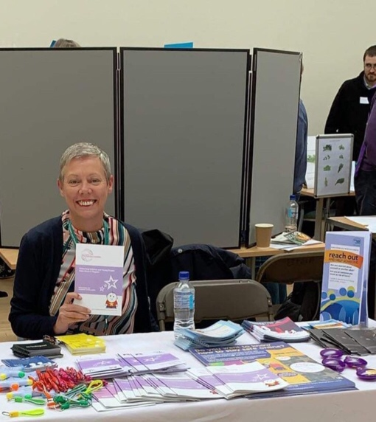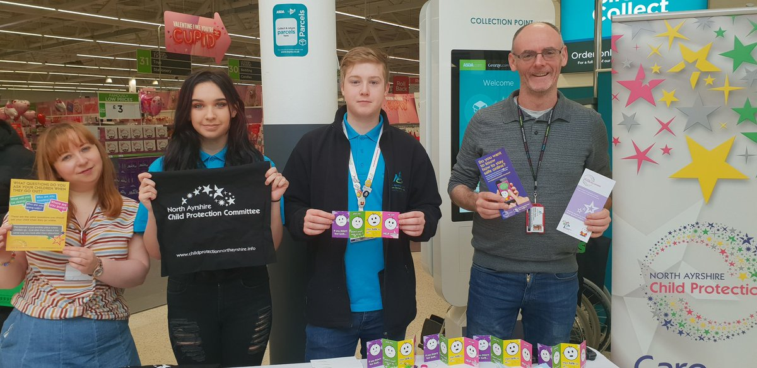

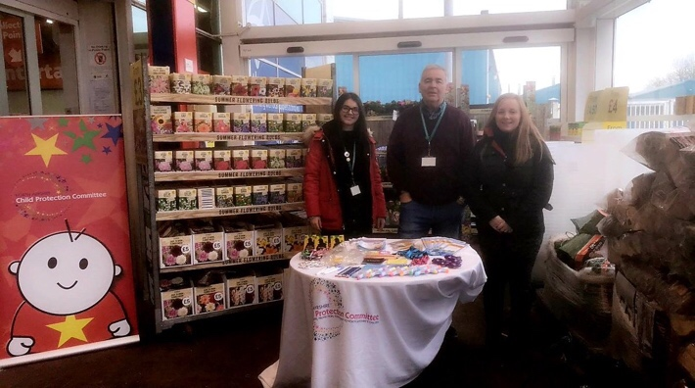

- The membership of young people (Corporate Parenting Modern Apprentice and Youth Modern Apprentice) on the CPC Public Information and Engagement sub-group.

- The launch of the 13 Ways Suicide Prevention animation campaign, young people were central to developing the language, visuals and stories, and were supported to contribute meaningfully specifically (but not exclusively) through the Year of the Young Person Ambassadors.

- Young people are in the process of conducting peer research with the overall aim of developing a mental health suicide prevention toolkit to support peers.

- Feedback was collected from young people with regards to their experiences of Child Protection processes, which supported the formation of the evaluation report for North Ayrshire CPC.
OUTCOMES

- Adults, children and communities are engaging with events and receiving information in relation to child protection and appropriate contacts. The public have an increased awareness of their responsibilities and who to contact.

- Parents and carers have an increased awareness of online safety and how to keep their children safe.

- Children and young people are better protected

- Participants from a range of agencies across North Ayrshire are informed by the voices of young people.

- Report established which explores children’s views on their participation and involvement in CP processes and this will shape how the CPC takes actions forward as a consequence of the feedback.

- Agencies have worked in partnership with young people to ensure that their voices are acknowledged in the young people’s suicide prevention communication strategy.

- Young people have influence on how the CPC engages with the public in relation to Child Protection messages

SELF EVALUATION STATEMENT

Children, young people, families, members of the public and professionals in North Ayrshire receive information about child protection and the work of the Child Protection Committee in a number of different ways.

Children and young people in North Ayrshire have opportunities to have their views heard and taken account of in child protection planning.

2. Continuous Improvement

KEY ACHIEVEMENTS

- Development of a multi-agency Young People’s Suicide Crisis Response Plan. http://childprotectionnorthayrshire.info/cpc/media/2018/12/CRISIS-RESPONSE-PLAN-with-appendices.pdf
- Development of Suicide Prevention Risk Assessment & Safety Planning Guidance for education staff.

The amalgamation of the evaluation and improvement plan and CPC business action plan.

Introduction of quarterly monitoring of CPC Business Outcomes.

Robust evaluation activity in relation to children and young people’s experiences of being involved in Child Protection processes.

Quality assurance of JII Practices within North Ayrshire in collaboration with the West of Scotland JII co-ordinator.

Relaunched AYRshare within the Health and Social Care Partnership and an implemented quality assurance framework based on the new AYRshare standards.

Analysis and improvement in the number of children and young people remaining within their family home following Child Protection de-registration.

A new Chair confirmed for the Evaluation and Improvement sub-group.
- Continued successful implementation of PRISM which has supported practitioners to reflect on child protection cases and improve professional practice.

- North Ayrshire’s strategic and operational response to suicide prevention in young people has been shared with national colleagues and is available on the CPC website.

- The co-ordination of a Suicide Crisis Response Table Top exercise in collaboration with Police Scotland.

- A multi-agency reflective session was facilitated for members of the Young People’s Suicide Taskforce who were involved in the crisis response plan initiation when a young person completed suicide.

- The CPC delivered an input to the Health and Social Care Partnership Leadership course in relation to the SCR.

- A new CPC Learning and Development Co-ordinator was recruited in post in September 2018.

- Successful delivery of the 2018 multi-agency training programme and launch of 2019 programme
http://childprotectionnorthayrshire.info/cpc/training/

- The delivery of Child Protection in the Family workshops to adult services workers in collaboration with the HSCP Learning and Development Team.

- The introduction of Break the Silence training on the CPC calendar, which will develop practitioners knowledge and skills when working with children affected by Child Sexual Abuse (CSA).

- A new redesigned format of the Getting Our Priorities Right training, which is now workshop based and is jointly delivered with operational workers who work with families impacted by parental substance misuse.

- Bespoke Child Protection training sessions delivered to sports and tenancy groups.

OUTCOMES

- Multi-agency staff have clear guidance to protect and support children and young people in the event of a young person completing suicide.
- Education staff have appropriate and consistent guidance to respond to suicide concerns in young people.
- A comprehensive, focused plan to monitor improvement activity and how this correlates with the CPC business outcomes

- Implementation of learning from evaluation activities.

- Improved outcomes for children subject to CP processes.

- Practitioners across services in North Ayrshire have access to increased opportunities for multi-agency reflection and learning resulting in improved services to children

- North Ayrshire shares relevant local learning across Ayrshire and nationally in Scotland

- Increased levels of staff from key agencies attending child protection learning and development opportunities.

- Staff have access to courses which are continually updated to reflect current best practice.

- Services feel more confident and competent in responding to child protection issues.

SELF EVALUATION STATEMENT

NACPC works with partners to develop and regularly update written guidance and procedures in order to support consistent child protection practice which is based on current knowledge and research with the aim of contributing to prevention of completed suicides and positive mental health of children and young people.

Children and young people in North Ayrshire receive services which are subject to a rolling programme of self evaluation and improvement.

NACPC takes opportunities to learn from review of local practice and effectively shares this learning to promote continuous improvement.

Children and families receive services from a workforce which takes opportunities for learning and development to enhance skills in practice.

3. Strategic Planning and Connections

KEY ACHIEVEMENTS

- North Ayrshire Alcohol and Drug Partnership and North Ayrshire Child Protection Committee continue to implement a joint sub-group in respect of Children Affected by Parental Substance Misuse (CAPSM).

- North Ayrshire Child Protection Committee continues to be an active member of North Ayrshire Violence Against Women Partnership.

- The Child Protection Lead Officer is a member of the Adult Support & Protection Committee and has built strong links with the Adult Protection Team.

- Existing local, regional and national connections continue.

- An annual Child Protection input and awareness raising session was delivered to Elected Members in collaboration with the Adult Support & Protection Committee

- The Child Protection Committee Independent Chair is a member of North Ayrshire’s Children’s Services Strategic Partnership

- NACPC Development Day held in November 2018 to review, discuss and agree the CPC business plan for financial year 2019/2020.

- North Ayrshire Child Protection Website is updated and is used by staff and the public. This is further complimented by the launch of the CPC Twitter platform.

- Demonstration of effective communication at Committee and subgroup meetings, including improved reporting on subgroup activity

- The CPC Lead Officer became the new Chair of the West of Scotland Lead Officer’s group.

- Regular networking takes place locally, regionally and nationally

OUTCOMES

- Continuing relationships across the Public Protection planning fora.

- Shared learning between Adult Protection Committee and Child Protection Committee

- Elected Members have increased knowledge and awareness of child protection issues in North Ayrshire and feel better equipped to effectively contribute.

- North Ayrshire Child Protection Committee has a focused business plan which is agreed by all CPC members which responds to the protection needs of children and young people

- North Ayrshire Child Protection Committee demonstrates effective communication with other Child Protection Committees across Scotland.

SELF EVALUATION STATEMENT

We believe we have strong relationships with key strategic partnerships in North Ayrshire which facilitate collaboration and shared learning to the benefit of children and families.

Effective communication and co-operation is demonstrated at all levels by those involved in the planning, design and delivery of services to protect children and young people.

CHANGING CHILDREN’S SERVICES FUND
BUDGET ALLOCATION APRIL 2018 – MARCH 19
Income
Total Budget Allocated from HSCP | £138,559
Contribution from Police | £ 11,446
Total | £ 150,005
Expenditure
Employee Costs | £112,033
Running Costs (including Hospitality) | £9706
Public Information and Awareness Raising | £3528
Payments to other bodies | £21,811
Total | £147,078

MEMBERSHIP OF

North Ayrshire Child Protection Committee (July 2019)

 | TITLE/DESIGNATION | NAME | AGENCY
 | Chair | Anne Houston | Independent Chair
 | Vice Chair – Director | Stephen Brown | North Ayrshire Health and Social Care Partnership
 | Child Protection Lead Officer | Kirsty Calderwood | NA CPC
 | Child Protection Learning and Development Co-ordinator | Alison Linton | NA CPC
 | Head of Service, Children’s Services | Donna McKee | North Ayrshire Health and Social Care Partnership
 | Reporter Manager | Alan Mulrooney | SCRA
 | Senior Manager, Children & Families | Elizabeth Stewart | North Ayrshire Health and Social Care Partnership
 | Chief Social Work Officer | David MacRitchie | North Ayrshire Health and Social Care Partnership
 | Head of Midwifery | Attica Wheeler | NHS Ayrshire & Arran
 | Consultant Paediatrician (Child Protection) | Dr Mona Rahim | NHS Ayrshire & Arran
 | Nurse Consultant for Child Protection | Marina McLaughlin | NHS Ayrshire & Arran
 | Superintendent | Colin Martin | Police Scotland
 | Housing Operations Manager | Robert McGilvery | North Ayrshire Council
 | Assistant Director | Fiona McBride | Children 1st
 | Head of Service, Education & Youth Employment | Caroline Amos | North Ayrshire Council
18. | Associate Nurse Director | David Thomson | North Ayrshire Health and Social Care Partnership
21. | Senior Manager Universal Early Years | Dalene Sinclair | North Ayrshire Health and Social Care Partnership
22. | Head of Service, Adult & Mental Health Services | Thelma Bowers | North Ayrshire Health and Social Care Partnership
23. | Clinical Director | Dr Paul Kerr | North Ayrshire Health and Social Care Partnership
24. | Head of Service, Connected Communities | Audrey Sutton | North Ayrshire Council
25. | Team Manager, Legal Services | Eleanor McLaren | North Ayrshire Council
26. | Interim Senior Manager, Intervention Services | Roseanne Burns | North Ayrshire Health and Social Care Partnership

MEMBERSHIP OF THE

CHIEF OFFICER’S GROUP

 | TITLE/  DESIGNATION | NAME
1. | Craig Hatton (October 2018 – Present)  Elma Murray (Retired September 2018) | Chief Executive, North Ayrshire Council  Former Chief Executive, North Ayrshire Council
2. | John Burns | Chief Executive, NHS Ayrshire & Arran
3. | Mark Hargreaves (April 2019 – Present)  Paul Main (Retired March 2019) | Divisional Commander, Police Scotland ‘U’ Division  Previous Divisional Commander, Police Scotland ‘U’ Division

MEMBERSHIP OF NA CPC PUBLIC INFORMATION & ENGAGEMENT SUB GROUP (July 2019)

NAME | TITLE | ORGANISATION
Dalene Sinclair (Chair) | Senior Manager Universal Early Years | NA Health & Social Care Partnership
Kirsty Calderwood | Child Protection Lead Officer | NA CPC
Alison Linton | Child Protection Learning and Development Co-ordinator | NA CPC
Andrew Keir | GIRFEC Manager | NA Health & Social Care Partnership
Conner Henderson | Corporate Parenting Modern Apprentice | NA Health & Social Care Partnership
Bruce Jackson | Marketing & Events Officer | North Ayrshire Council
Kirsty Aitken | Children 1st Manager | Children 1st
Tracey Carswell | Clinical Team Leader | NA Health & Social Care Partnership
Damian Taylor | Community Education Worker | Youth Services, North Ayrshire Council
Fiona Hopkins | Senior Manager | Education, North Ayrshire Council
Sharon Johnstone | Head teacher | Education, North Ayrshire Council
Susan Milloy | Detective Inspector | Police Scotland
Jason Peter | Local authority Liaison Officer | Police Scotland

2018/2019 Group Remit

Group Purpose:
To develop, implement and oversee the North Ayrshire Child Protection Committee Communications Strategy.

Group Objectives:
1 | To ensure public information in relation to child protection is widely available, in a range of materials, to children, young people, families, professionals and members of the public.
2 | To ensure an ongoing public awareness campaign in relation to child protection.
3 | To promote the work of North Ayrshire Child Protection Committee.
4 | To ensure the views of children, young people and their families are clearly evidenced in the work of North Ayrshire Child Protection Committee.
Group Tasks:
1 | Continue to implement the NACPC Communications Strategy.
2 | To identify and utilise opportunities for promoting child protection within the local community via a Public Engagement Plan.
3 | To monitor inventory of promotional materials, literature and guidance documents.
4 | To regularly update and continually promote the NA CPC websites and Twitter page.
5 | Actively consult with children and young people in relation to relevant projects.
6 | Maximise the use of audio/visual products and information packs which help represent the voice of the child/young person.
7 | Engage with local taxi drivers with regards to child protection awareness.
8 | Utilise social media to promote key child protection messages.
Outcomes:
1 | Increased awareness of child protection across the population of North Ayrshire.
2 | NA CPC have an online presence where both members of the public and professionals can access information.
3 | The perspective of children in the child protection system is better understood by practitioners and better reflected in meetings.
4 | Materials are informed by the perspective of children and young people.
5 | Groups within the wider community are more engaged with protecting children.

MEMBERSHIP OF NA CPC EVALUATION SUB GROUP (July 2019)

NAME | TITLE | ORGANISATION
Evelyn Martin (Newly Appointed Chair) | Quality and Improvement Officer | Education, North Ayrshire Council
Kirsty Calderwood | Child Protection Lead Officer | NA CPC
Frances MacIntyre | Child Protection Advisor | NHS A&A
Susan Milloy | Detective Inspector | Police Scotland
Eleanor McLaren | Solicitor | Legal & Protective Services
Alan Mulrooney | Reporter Manager | Scottish Children’s Reporter Administration
Shelagh Campbell | Team Manager, Homelessness & Community Safety | Housing Services, NAC
Philip Gosnay | Senior Manager | Education, North Ayrshire Council
Evelyn Berry | Clinical Team Leader | NA Health & Social Care Partnership
Ruth Davie | Senior Manager Practice & Policy | NA Health & Social Care Partnership
Alison Linton | Learning & Development Coordinator | NA CPC
Andrew Keir | GIRFEC Manager | NA Health & Social Care Partnership
Peter McArthur | Senior Manager, Addictions | NA Health & Social Care Partnership
Gail Stirling | Team Manager | Richmond Fellowship Project
Dalene Sinclair | Senior Manager, Universal Early Years | NA Health & Social Care Partnership
Elizabeth Stewart | Senior Manager, Fieldwork | NA Health & Social Care Partnership
Susan Hamilton | Head Teacher | Education, North Ayrshire Council

Remit

Evaluation and Improvement Sub Group

Group Purpose:
To have an overview of single agency and inter-agency auditing, evaluation and quality assurance systems to ensure that robust mechanisms are in place that inform improvements to services to protect children and young people in North Ayrshire.
Group Objectives:
1 | To oversee the implementation of a multi agency self evaluation strategy.
2 | To support the continuous improvement of services to protect children and young people.
3 | To ensure application of lessons learned from Inquiries, Inspections and Initial/Significant Case Reviews (Improvement Plan)
Group Tasks:
1 | Develop and implement a multi agency self evaluation strategy.
2 | Monitor improvement plans.
3 | Share single agency audit and evaluation activity with the group.
4 | Contribute to multi agency evaluation portfolio of evidence.
Outcomes:
1 | Multi agency self evaluation strategy is implemented.
2 | Services to protect children and young people in North Ayrshire are subject to a programme of continuous improvement.
3 | Continuous improvement programmes are informed by messages from Inquiries, Inspections and Case Reviews.
4 | Children get the help they need when they need it.
5 | Children and young people in North Ayrshire receive services informed by best practice findings.

MEMBERSHIP OF NA CPC MANAGEMENT INFORMATION SUB GROUP (July 2019)

NAME | TITLE | ORGANISATION
Donna McKee | Head of Service, Children’s Services | NA Health & Social Care Partnership
Kirsty Calderwood | CPC Lead Officer | NA CPC
Frances MacIntyre | Child Protection Advisor | NHS A&A
Elizabeth Stewart | Senior Manager | NA Health & Social Care Partnership
Mark Inglis | Senior Manager | NA Health & Social Care Partnership
David MacRitchie | Chief Social Work Officer | NA Health & Social Care Partnership
Alan Mulrooney | Reporter Manager | SCRA
Stuart Singleton | Performance Officer | NA Health & Social Care Partnership
Johanna House | Senior Manager | Education
Susan Milloy | Detective Inspector | Police Scotland

Remit

Management Information Sub Group

Group Purpose:
To ensure the Child Protection Committee is able to maintain an overview of management information from all key agencies about their work to protect children and young people.
Group Objectives:
1 | To identify and take appropriate action in response to trends in relation to child protection issues in North Ayrshire
2 | To ensure Integrated Children’s Services Planning is informed by accurate and meaningful child protection data
3 | To utilise child protection management information to better protect children and young people
Group Tasks:
1 | Review the child protection management reports prior to submission to NACPC
2 | Analyse the data gathered by key agencies and use to inform and shape service planning and delivery.
Outcomes:
1 | NACPC is fully informed about child protection trends in North Ayrshire
2 | Children’s Services Planning are fully informed about child protection trends in North Ayrshire
3 | Services for children and families in North Ayrshire meet local need

MEMBERSHIP OF NA CPC LEARNING & DEVELOPMENT SUB GROUP (July 2019)

NAME | TITLE | ORGANISATION
Angela Morrell | Senior Manager | Communities
Alison Linton | Learning & Development Co-ordinator | NA CPC
Frances MacIntyre | Child Protection Advisor | NHS A&A
Eilidh Wilson | Locality Reporter Manager | Scottish Children’s Reporter Administration
Lesley Higgins | Learning & Development Manager | NA Health & Social Care Partnership
Alison Allan | Senior Manager | Education, North Ayrshire Council
Leanna Grant | Youth Worker | Children 1st
Robert McGilvery | Senior Housing Operations Manager | Housing, North Ayrshire Council

Remit

Learning and Development Sub Group

Group Purpose: To have an overview of single and inter agency child protection training and ensure that this training meets national and local objectives in contributing to the protection of children and young people in North Ayrshire using a robust evaluation system.
Group Objectives:
1 | Agree, prioritise and evaluate multi agency training.
2 | Ensure multi agency training meets local and national needs.
3 | Produce a annual child protection training plan
4 | Ensure that the training programme reflects and contributes to continuous improvements in services to protect children and young people.
Group Tasks:
1 | To develop on multi agency training programme.
2 | Organise a range of joint training opportunities / events for staff.
3 | Assist and support single agency training programmes.
4 | Feedback any training issues to NA CPC arising from practice developments, Inquiries or policy developments.
5 | Evaluate and report back on attendance of staff at training events and any related issues.
6 | Monitor, evaluate and report the outcomes and completed tasks back to NA CPC.
Outcomes:
1 | An annual child protection training programme in place.
2 | Staff benefit from joint training with colleagues from other services and have a high level of participation in training events.
3 | Staff confidence and competence in providing quality services to children and young people are increased.

North Ayrshire ADP/CPC CAPSM Sub Group (July 2019)

NAME | TITLE | ORGANISATION
Roseanne Burns (Chair) | Interim Senior Manager | NA Health & Social Care Partnership
Post Vacant | Alcohol and Drug Lead Officer | NA ADP
Kirsty Calderwood | Child Protection Lead Officer | NA CPC
Graham Lindsay | Team Manager, Addictions | NA Health & Social Care Partnership
John Flanagan | Team Manager | NA Health & Social Care Partnership
Corry McDonald | Team Manager | NA Health & Social Care Partnership
James Hill | Advanced Nurse Practitioner | NHS Ayrshire & Arran
Elaine Crilly | Principal Teacher, Pupil Support Service | Education, NAC
David Weir | Service Manager | North Ayrshire Carers Centre
Alison Gibson | Service Manager | Barnardos
Colin Johnson | Police Officer | Police Scotland
Jillian Dowds | Clinical Team Leader | NHS Ayrshire & Arran
Louise Wilson | GP | NA Health & Social Care Partnership
Arthur Coutts | Team Manager, Kinship Care | NA Health & Social Care Partnership

Remit

CAPSM

The North Ayrshire Children Affected by Parental Substance Misuse Group (CAPSM) will work to improve the quality and accessibility to services for Children and Young People who are at risk due to the harmful effects of parental / care giver alcohol and / or drug misuse.
The CAPSM Group is a recognised sub-group of the North Ayrshire Alcohol and Drug Partnership (ADP) and the Child Protection Committee (CPC), and will link with other strategic Community Planning groups.

Objectives:
- To strengthen understanding across agencies of needs of children and young people affected by parental substance misuse.
- To support partners in developing an effective inter-agency response to children and young people affected by parental substance misuse.
- To strengthen communication links & joint working between adult and children’s services.
- To ensure all developments in this area are aligned with the wider GIRFEC change agenda developments in North Ayrshire and that cognisance is taken of linked to relevant strategies including the Early Years Framework and the Parenting & Family Support Strategy.

North Ayrshire Young People’s Strategic Suicide Prevention Group (YPSSPG) (July 2019)

NAME | TITLE | ORGANISATION
Anne Houston (Chair) | NACPC Independent Chair | NA CPC
Stephen Brown (Deputy Chair) | Director | NA Health & Social Care Partnership
Caroline Amos | Head of Service | Education
Kirsty Calderwood | CPC Lead Officer | NA CPC
David Thomson | Lead Nurse | NHS A&A
Thelma Bowers | Senior Manager | NA Health & Social Care Partnership
David MacRitchie | Chief Social Work Officer | NA Health & Social Care Partnership
Lynne McNiven | Interim Director | Public Health
Colin Martin | Superintendent | Police Scotland

Remit

YPSSPG

The primary objective of the YPSSPG is to reduce the instances of suicides by young people within North Ayrshire.

The strategic objective will be achieved by:

- Establishing specific multi-agency governance arrangements for partnership working
- Monitor risk factors including instances of suicide and attempted suicide
- Develop effective response mechanisms for emerging risk factors
- Establish an overarching Suicide Prevention Community Action Plan and monitor its development and implementation
- Ensure best practice information sharing and collaborative working with partner Local Authorities

North Ayrshire Young People’s Suicide Taskforce (Formerly known as the Young People’s Operational Suicide Prevention Group) (July 2019)

NAME | TITLE | ORGANISATION
Kirsty Calderwood (Chair) | CPC Lead Officer | NA CPC
Lynne McNiven (Co-chair) | Interim Director | Public Health
Sam March | Principal Educational Psychologist | Education
Evelyn Martin | Quality Improvement Officer | Education
Colin Convery | Police Inspector | Police Scotland
Pete Gilfedder | Senior Nurse | NHS A&A
Sarah Watts | Choose Life Co-ordinator | NA Council
Angela Morrell | Senior Manager | Communities
Stephen Colligan | Head Teacher | St Matthews Academy, Education
Tommy Stevenson | CAMHS Manager | NHS A&A
Valerie Warwick | GP | NHS A&A

Remit

Young People’s Suicide Taskforce

The Primary Objective of the Young People’s Suicide Taskforce is take forward actions in response to recent deaths and to reduce the instances of young people suicides in North Ayrshire.

The above objective will be achieved by:

- Implementing the Strategic Group actions
- Keeping the Strategic Group informed
- Producing a short to medium term Community Action Plan
- Planning, recording and monitoring all identified actions
- Sharing relevant information and updates
- Communicating effectively across all partners and with teams and services
- Identifying and alerting partners to those at risk through regular data assessment
- Listening to and responding jointly to those services directly affected by recent events
- Responding across the authority with consistent, shared messages

1. Well-being and Vulnerability

WBV1 | Priority: Addressing vulnerability in pregnancy  We will provide additional support to vulnerable women and their partners where circumstances arise that may adversely impact on the unborn child. Initial evaluation feedback is indicating that the introduction of a dedicated child protection team is reducing the time scales to convene pre-birth conferences where they are required. This will continue to be monitored via the Management Information Subgroup.
 | Task | Lead | Timescale | Outcome | Progress | Notes
WBV1a | There will be a meeting convened once per month in Cunninghame House between the Child Protection Advisor; the Safeguarding Midwifery (SMW) Charge Nurse and the Social Work Team Leader of the Child Protection Team, C&Fs, Irvine to screen all North Pre-birth Assessments (PBAs) submitted from the SMW Team to decide on how to address the concerns raised. | Frances MacIntyre | June 2018 | Any urgent PBAs received outwith the monthly meeting will be discussed timeously and not left for the next monthly screening meeting. This will be measured and monitored via the Management Information Group. |  | Completed at previous meeting
WBV1b | The effectiveness of the dedicated child protection team in reducing time scales to convene pre-birth conferences will be reviewed regularly at the Management Information Group, and actions will be agreed as necessary to support the reduction in time for children who are required to be subject to a case conference. | Donna McKee | March  2019  (Ongoing) | The risks for unborn children are quickly established to ensure that they are safe, and parents receive early interventions to support them in the care of their child. This will be measured and monitored via the Management Information Group. |  | Improvement being recognised and ongoing monitoring  continues within the  Management  Information Group.

WBV2 | Priority: Safeguarding missing children and young people  We will support the implementation of the National Missing Persons Framework for Scotland and co-ordinate learning and development opportunities for multi-agency staff, enabling them to make better use of opportunities to discuss missing episodes with children and young people with the intention of providing necessary supports and reducing the risk of further missing episodes.
 | Task | Lead | Timescale | Outcome | Progress | Notes
WBV2a | A multi-agency short life working group will be established to take forward the Implementation of the National Missing Person’s Framework within North Ayrshire. | Kirsty Calderwood | November 2018 | NACPC will have an informed position in respect of the strategy which will support the prevention of young people going missing and limiting the harm associated when they do go missing.  Feedback will be obtained from both agencies and young people to assess the long term impact of the framework. |  | Completed at previous meeting
WBV2b | Return discussion national best practice will be taken forward through learning and development opportunities for staff. | Alison Linton | November 2018 | Young people who require to engage in return discussions will receive appropriate support following a missing episode. As described above, feedback will be obtained from young people to evaluate the impact of this. |  | Action taken forward within business action plan 2019/2020.

WBV3 | Priority: Supporting children in their early years  We will do further investigative work, through the Management Information sub group, to better understand why there are increasing numbers of children under five years of age on the Child Protection Register. This will be brought to the CPC for consideration and we will use this understanding to improve support to vulnerable families with infant children.
 | Task | Lead | Timescale | Outcome | Progress | Notes
WBV3a | Expand universal early years services (resources such as perinatal nurses, family nurturer etc) to ensure that families are supported at the earliest stage. | Dalene Sinclair/  Donna McKee | Jan 2019 | Vulnerable families will receive support through early intervention which will mean that children are getting the best start in life from their caregivers, and will help prevent child protection registration. This will be measured and monitored via the Management Information Group. |  | Completed at previous meeting
WBV3b | The number of children under 5 on the Child Protection Register will continuously be reviewed and analysed at the Management Information Group by all members quarterly, and this information will be utilised to improve support to families with vulnerable children. | Management  Information Group | Quarterly  (Aug  2018,  Nov  2018, Feb  2019) | Infants receive the necessary supports to ensure that they are safe. This will be measured and monitored via the Management Information Group.

WBV4 | Priority: Addressing the impact of poverty and its links with child protection  We will analyse indicators in relation to the links between poverty and the protection of children within areas in North Ayrshire, and take a localised approach to address what preventative and supportive measures can ensure that children are safe and that their needs are being met. We will ensure our findings are communicated to inform wider strategic planning.
 | Task | Lead | Timescale | Outcome | Progress | Notes
WBV4a | Indicators such as SIMD status and links to child protection statistics will be reviewed and analysed by members of the Management Information Group. | Management  Information Group | Quarterly  (Aug  2018,  Nov  2018, Feb  2019) | Findings will help inform practice and a strategic plan in response to the links between poverty and child protection. This will be measured and monitored via the Management Information Group. |  | SIMD status been introduced into MIG report. Ongoing work with performance re. analysis of SIMD/CP linkages. MIG continue to analyse and report to CPC.
WBV4b | The findings described above will be communicated to necessary stakeholders such as NACPC, NACSSP and elected members. | Kirsty Calderwood | March 2019 | A strategic plan will mean that preventative and supportive measures can be put in place to ensure that children’s safety needs are being met. |  | Complete

WBV5 | Priority: An improved response to the mental health needs of children and young people  We will deliver improvements in response to recent Case Reviews, ensuring that appropriate mental health preventative and support strategies are in place for children and young people. We will continue to strengthen the relationships between adult mental health and children’s services as identified in our Significant Case Review, and continue to improve awareness of the impact of adult mental health on children and young people.
 | Task | Lead | Timescale | Outcome | Progress | Notes
WBV5a | A crisis response plan will be developed to ensure that there is an effective and efficient multi-agency response in the event of a future young person completing suicide. | Young People’s Suicide Taskforce | May 2018 | Communities will receive the necessary support in the event of a future youth suicide, and agencies will work together to protect and support young people in the immediate aftermath. Following this, the effectiveness of the crisis plan would be evaluated and assessed by members of the Young Person’s Strategic Suicide Group. |  | Completed at previous meeting.
WBV5a | A mapping exercise will take place in relation to wellbeing/mental health support for children and young people within North Ayrshire. | Young People’s Suicide Taskforce | August 2018 | This will help identify gaps in support and provision that can be put in place for young people. |  | Completed at previous meeting.
WBV5b | Safe plans and guidance will be reviewed in relation to emotional wellbeing and suicide prevention within education, and consultation work will take place with young people to help inform this piece of work. | Young People’s Suicide Taskforce | Original date:  August  - June  - (Changed timescale – to be continued next year) | Young people are emotionally safe and receiving the necessary support to meet their mental health needs. Young people will be listened to in relation to what their needs are and how agencies best support them. Feedback will be obtained from young people and education staff in relation to the effectiveness of resources that are developed. |  | Safe plans and guidance has been reviewed, guidance in the process of being finalised with plans to launch in August 2019.
WBV5c | Scottish Mental Health First Aid, Asist training and Safetalk will be rolled out to education staff within North Ayrshire. | Young People’s Suicide Taskforce | March 2019 | Education staff feel equipped to ensure that young people are emotionally safe and are able to signpost to the necessary supports. Sarah Watts (Choose Life Co-ordinator) will provide evaluation feedback on the effectiveness and impact of the training. |  | Follow up meeting for ASIST trained education staff has taken place to keep staff supported. A further ASIST course has not yet been planned. Proposed Kilwinning pupils safeTALK date had to be cancelled and a future date to be arranged. SMHFA continues as planned. National uncertainty about support for these training programmes as well as limited trainer capacity locally has

affected some future planning although it is
hoped to fulfil these commitments

Update Scottish
Mental Health First
Aid, Asist training and Safetalk will be rolled out to education staff within North Ayrshire.

This target was a 2 year target so we are on track for March 2019. We have delivered one ASIST and planning another for June 2019. We have delivered 2 pupil safeTALKs and with 2 more trainers available plans to deliver on Arran and Largs/Garnock are underway.

Nationally still unsure of the future but we are sustaining plans locally.
WBV5d | Youth services, police staff and the third sector have access to mental health training opportunities. | Young People’s Suicide Taskforce | March 2019 | Training opportunities to staff means that services who engage with young people are able to risk assess mental health needs and signpost to necessary supports. Sarah Watts (Choose Life Coordinator) will provide evaluation feedback on the effectiveness and impact of the training. |  | This work is ongoing and a safeTALK has been delivered to youth work staff and Modern Apprentices. Links are made between Youth Services and Choose Life manager and will respond to further requests as required. All campus police officers trained in  SMHFA-ongoing links between police and
 |  |  |  |  |  | Choose Life manager for any further training requests. 3rd sector links are maintained and bespoke training organised and delivered as required. National uncertainty about support for these training programmes as well as limited trainer capacity locally has affected some future planning.
WBV5e | Adult Mental health and Addiction workers will routinely consider and when appropriate raise concerns for children’s wellbeing who are in contact with adult service users. | Thelma Bowers | October 2018 | The impact of adult mental health on young people is recognised, and relevant action is taken in response to this. This will be monitored via the Evaluation and Improvement Group. |  | No update provided for May 2019 CPC Lead Officer Update: Feb 2019 update indicated that significant training has been facilitated to adult service workers in relation to trauma training and NRF training will be continuing in next year’s business plan.

WBV6 | Priority: The development of a suicide community action plan  We will form a strategic and operational multi agency working group to develop a suicide community action plan in response to a cluster of youth suicides within North Ayrshire with the intention of reducing the risk of further incidents and ensuring consistent support is provided to young people incorporating outcomes of research and other good practice evidence.
 | Task | Lead | Timescale | Outcome | Progress | Notes
WBV6a | A strategic and operational young person’s suicide prevention group will be established with the aim of improving young people’s emotional wellbeing and reducing the instances of young people completing suicide. | Anne Houston / Kirsty Calderwood | April 2018 | The aim of these groups will be to improve young people’s wellbeing and to reduce the instances of young people completing suicide. |  | Completed at previous meeting.
WBV6b | A community action plan will be formed and the Young People’s Suicide Taskforce will deliver the actions from this plan. | Kirsty Calderwood | April 2018 | Young people’s mental health and emotional wellbeing needs will be met with the aim of reducing the instances of young people completing suicide. The plan will be reviewed 6 monthly by the Young People’s Suicide Taskforce. |  | Completed at previous meeting.

Engagement and Empowerment

E&E1 | Priority: Revising our NACPC Communication Strategy  We will review our communication strategy annually, to ensure that our messages are responsive to the communities within North Ayrshire and engage with vital stakeholders who are instrumental in keeping children safe. This will form part of the work plan for the Public Information and Engagement Subgroup.
 | Task | Lead | Timescale | Outcome | Progress | Notes
E&E1a | The communications strategy will be updated, and will thereafter be reviewed annually. to ensure that NACPC is effective in engaging communities and stakeholders. | Nicola Murphy / Kirsty Calderwood | March 2019 | This will ensure that NACPC is effective in engaging communities and stakeholders, and will be monitored and measured annually via the Public Information Engagement group. |  | Completed at previous meeting.

E&E2 | Priority: Actively involving children and their families in all child protection processes, and practitioners adopting a more child centred approach to ensure that support is individualised to meet their needs. We will continue to review and analyse the involvement of children through the Management Information Group, Evaluation and Improvement Group and Public Information and Engagement Group, and will use this information and feedback to further improve service user involvement and as appropriate, their roles in decision making.
 | Task | Lead | Timescale | Outcome | Progress | Notes
E&E2a | Visual tools and resources will be developed for children and young people to become more involved in child protection conferences. | Ruth Davie | December 2018 | Children and young people have an active voice within Child Protection Case Conferences. This will be monitored and measured via the Evaluation and Improvement group. |  | Completed at previous meeting.
E&E2b | A CPC conference will be held to celebrate ‘Year of the Young Person’ which will be steered by young people. | Louise Henry | June 2018 | The CPC Conference will be significantly informed and developed by young people. Feedback will be obtained from the young people participating in the event, and direct activity in relation to child centred approaches in child protection practice. |  | Completed at previous meeting.
E&E2c | An evaluative piece of work will be undertaken by the Evaluation and  Improvement sub-group to assess engagement and involvement of children in child protection processes. | Evaluation and  Improvement  Group | September 2018 | There will be further insight into how children and caregivers are involved in child protection processes and this will direct actions taken forward. |  | Completed at previous meeting.
E&E2d | Findings from the work described above will be shared with the Public Information and Engagement group, which will direct activity in relation to how agencies meaningfully engage with children and young people, and methods that are used for receiving feedback. | Public Information and Engagement  Group | March 2019 | Children and young people are listened to by practitioners and their feedback is used to improve the involvement of children and young people during all stages of child protection processes. |  | Action continued into next year’s business plan.
E&E2e | Children and care givers involvement in child protection processes will be continuously be reviewed and analysed within the Management Information Group. | Management  Information Group | Quarterly  (Aug 2018,  Nov 2018,  Feb 2019) | This data will be monitored quarterly to help inform the above pieces of work to monitor improvements as to how agencies are ensuring that children and young people’s views and perspectives are considered. |  | MIG monitoring closely with recommendations from current MIG to  Senior Manager for CP/fieldwork to review processes and
practice to see
improvement around child experience. This will continue to be analysed within the MIG and brought to CPC member’s attention.

E&E3 | Priority: Harnessing assets within the community by engaging with stakeholders to support their understanding of their role and sense of efficacy in the protection of children  We will continue to develop and deliver practice development child protection sessions to key stakeholder groups in the community, such as taxi drivers and local sports and community groups. We will also support the development of child protection guidance and procedures with stakeholders within local communities.
 | Task | Lead | Timescale | Outcome | Progress | Notes
E&E3a | Develop and provide child protection training for private taxi companies. | Public Information and Engagement  Group | Original  Timescale  June 2018 Revised action in 2019/2020 business plan | Taxi drivers have access to child protection training and are aware of the importance of their role in promoting children’s safety. Feedback will be received from participants of the training and will be measured via the Public Information and Engagement group. |  | PIE group discussed the training and feel that a resource for taxi drivers may be a useful way of increasing child protection awareness. New action continuing into new CPC business plan 2019/2020.
E&E3b | Use the learning from child protection training to agree on further stakeholder engagement activity. | Public Information and Engagement  Group | Original  Timescale Sept 2018 Changed timescale to  December  2019 | Our developing plan to engage community stakeholders is informed by learning from what works. |  | The PIE group will review the taxi training and look to expand this with other key stakeholders. This will be continued into next year’s business plan.
E&E3c | All staff in the PLACE directorate (facilities management, roads, waste resources etc) engage in basic child protection awareness and training as appropriate through the ‘Protecting People’ course. | L and D Coordinator / Adult  Support and  Protection  Committee | March  2019  (likely ongoing to next year) Revised action in 2019/2020 business plan | All staff within the PLACE directorate have a basic awareness of what to do if they are concerned in relation to the safety of a child. Evaluation feedback will be obtained from all participants of the course and will be monitored and measured via the CPC and APC Lead Officers. |  | PLACE staff have been provided with a range of options in relation to training methods and delivery – L and D co-ordinators awaiting feedback from PLACE staff. Action ongoing in next year’s business plan.

Learning and Improvement

L&L1 | Priority: Implementing the National Child Protection Improvement Programme  North Ayrshire Child Protection Committee will continue to review all actions and recommendations of the National Child Protection Improvement Programme and deliver the implementation plan to take these forward locally. We will participate with North Ayrshire’s Chief Officers in the Chief Officer Leadership Events, implementing recommendations locally.
 | Task | Lead | Timescale | Outcome | Progress | Notes
L&L1a | CPIP actions will be included within the amalgamated improvement plan, and will be reviewed at the Evaluation and Improvement sub-group and continue to be a standing agenda item at CPC meetings. | Kirsty  Calderwood | April 2018 | North Ayrshire is committed to taking forward actions from CPIP. |  | Completed at previous meeting.
L&L1b | The Learning and Development Sub Group have identified key areas of priority for focus with practice development – namely Neglect, Internet Safety and CSE. | Angela Morrell  Learning and  Development Sub  Group | June 2018 | Taking forward priorities within a practice development context. |  | Completed and being taken forward by new chair (Angela Morrell) and L and D Coordinator (Alison Linton).
L&L1c | Connected to a reviewed evaluation strategy one course per year will have a more intensive evaluation process to determine impact. In 2018 the focus will be Neglect. Action for Children’s Neglect Toolkit as part of course materials. | Alison Linton  Learning and  Development Sub  Group | Dec 2018 | In addition to the immediate evaluation – six months after completion of course line managers from each agency will be contacted to evaluate use and effectiveness of the toolkit for practitioners. |  | Completed at previous meeting.

L&L2 | Priority: Developing and implementing improvements based on the findings from our Significant Case Review and other learning opportunities  North Ayrshire Child Protection Committee will work collaboratively with all stakeholders to implement the amalgamated improvement plan based upon learning from our Significant and Initial Case Reviews undertaken in 2017/18 in order to better protect children and young people.
 | Task | Lead | Timescale | Outcome | Progress | Notes
L&L2a | An amalgamated improvement plan will be developed which includes improvement actions from ICRs, the SCR and CPIP actions. | Kirsty  Calderwood | April 2018 | This will be monitored and measured through the Evaluation and Improvement sub-group and will ensure that improvements are being actioned to improve outcomes for children. This will be a working tool which will be updated as necessary. |  | Completed at previous meeting.

L&L3 | Priority: Evaluating our Stop To Listen Pathfinder and utilising this learning to improve our response to child sexual abuse and exploitation  The Stop To Listen Pilot programme involving the 4 pathfinder areas is currently being evaluated and this will be reported into the CPC. We will use this evaluation to maximise learning and plan the continuation of implementation of Stop To Listen methodology across North Ayrshire over the coming year.
 | Task | Lead | Timescale | Outcome | Progress | Notes
L&L3a | A Child Sexual Abuse working group will be established to take forward the learning from the Stop to Listen project and ensure that North Ayrshire has an informed work position in response to CSE. | Alison Linton | July 2018 | The working group will develop a project action plan which will support the protection of children and young people from CSA. This will be monitored and measured via the Evaluation and Improvement group. |  | Completed at previous meeting.
L&L3b | We will listen to the learning from the other four pathfinders and from the National STL Steering Group and take this into account in our local planning. | Alison Linton | July 2018 | Best practice is taken forward within North Ayrshire. |  | Completed at previous meeting.
L&L3c | Our STL Project Plan will include measures and mechanisms to identify learning from our local experiences. | Alison Linton | Original timescale  October  2018 Action continuing in  2019/2020 business plan | Best practice is taken forward within North Ayrshire. |  | This will form part of a work plan which will be produced by the CSA working group. This work will be taken forward once there is an agreement in place re. a CSA strategy within North Ayrshire.
L&L3d | The Learning and Development Sub Group will receive information as to outcomes of the Pathfinder Evaluation and take forward priorities in relation to the identification and response to sexual abuse of children in North Ayrshire as well as further inputs to the multi-agency workforce regarding communicating with children and Children’s Rights. | Angela Morrell  Learning and  Development Sub  Group | Original timescale  October  2018 Action continuing in  2019/2020 | To ensure the workforce receive clear and consistent messages as to expectations of responses to sexual abuse of children – both prevention and retrospective response.  Any input would be measured via the Evaluation and Improvement Sub Group |  | The CSA working group will link closely into the  Learning and Development subgroup and take forward priorities in relation to this. Due to the L and D sub-group reconvening for the first time since
 |  |  | business plan |  |  | June 2018, this timescale has been changed.

L&L4 | Priority: We will provide a range of child protection learning and practice development opportunities which will ensure that practitioners and managers are equipped with the necessary knowledge and skills to implement and progress learning within their agencies.  This will form part of the work plan for the Learning and Development Subgroup.
 | Task | Lead | Timescale | Outcome | Progress | Notes
L&L4a | There will be an increasing use of pre and post course materials provided for multi-agency courses by the CPC. | Alison Linton | March 2019 | There are clearer connections and integration between operational practice and development for participating staff.. In addition to this line managers will have more information. This will be measured via evaluation process plus qualitative data in direct consultation with agencies as to impact |  | The new Learning and Development Co-  ordinator is taking this action forward and is in progress. Ongoing action which will continue to be monitored via the Evaluation and Improvement subgroup.
L&L4b | There will be an online resource created jointly with Adult Protection Committee named ‘Protecting People’ to access as a baseline protection elearning module. | Alison Linton  Johannah Lamont Paul Houston | June 2018 | Completion of course is confirmed via online assessment. This will allow the monitoring of numbers of staff who have accessed this resource. |  | Completed
L&L4c | The West of Scotland Consortium have written an online resource in relation to Chronologies. In addition to this written materials will be produced to accompany this resource that can be used in direct delivery. All CPC’s in the WoS will receive a funding request in May 2018 to commission and build the resource. | Alison Linton | October 2018 | The outcome will be that there is a resource that can be easily accessed, that can be further supported by direct facilitation and materials, that emphasises the importance of chronologies as a practice tool, and that there is a consistency of practice across the West of Scotland authorities which staff may move between. This will be measured via evaluation processes of L&D Sub Group in addition to connection with AYRshare Performance  Management Group and CPC Evaluation and Improvement Sub Group audits. |  | Animator has been sourced. L and D coordinator will continue to receive updates via the WoS group.
L&L4d | North Ayrshire HSCP have requested further practice development inputs for Social Work, Health and Education staff from SCRA. This will be coordinated on a multi-agency basis via the Learning and Development Sub Group of the Child Protection Committee. | Alison Linton | December 2018 | To further support practice in relation to systems, processes and practice regarding legal frameworks for children and young people. Outcomes will be measured via evaluation and via the Evaluation and Improvement Sub Group |  | Completed at previous meeting.

Risk Assessment and Analysis

RA&A1 | Priority: Continuing to develop our chronology practice  We will increase our efforts to improve this area of practice by supporting agencies to improve the use of chronologies by evidencing findings from our recent Significant Case Review and audit activity; with a specific emphasis on how this reduces risk and has a significant impact on children’s lives.
 | Task | Lead | Timescale | Outcome | Progress | Notes
RA&A1a | North AYRshare Performance Improvement Group is implementing Pan Ayrshire standards through the development and evaluation of an improvement plan. | Andrew Keir | Nov 2018 | An improvement plan will support the multi-agency use of AYRshare. This will be measured via the Performance Improvement Group. |  | Completed at last meeting.
RA&A1b | All chronologies will be analysed at every core group, child protection conference and supervision session to ensure these are actively being utilised. | Ruth Davie  Mae Henderson | Dec 2018 | Chronology use is embedded within North Ayrshire and will protect children. This will be monitored and measured via the Evaluation and Improvement group. |  | Audit activity taking place in relation to this and features in next year’s business plan 2019/2020.
RA&A1c | AYRshare Performance Indicators to be established through the Performance Improvement Group. Following this, Practitioners are actively involved in monthly auditing of children’s chronologies to highlight and learn from current chronology practice. | AYRshare  Performance  Improvement  Group, Andrew  Keir | Mar 2019 | Performance Indicators will support practitioners in using chronologies effectively to protect children. Practitioners understand how crucial chronologies are in risk assessment and analysis, and the learning from this activity is reflected within their own professional practice through the increased use of AYRshare. This will be monitored and measured via the AYRshare Performance Improvement Group. |  | Completed at last meeting.

RA&A2 | Priority: Improving child protection awareness within adult services  We will work with adult services to ensure that there is sufficient awareness of child protection and practitioners are clear regarding their responsibilities in keeping children safe.
 | Task | Lead | Timescale | Outcome | Progress | Notes
RA&A2a | The CPC to work in partnership with NAHSCP L&D Team to develop a child protection course for practitioners in adult services. | Alison Linton  Lesley Higgins | Dec 2018 | Workshops will be facilitated to ensure a large number of practitioners and managers access the course. Children and Families practitioners and managers will engage in these sessions to support communication, and understanding of risk. Vulnerable children who are in close contact with adults who have problems with addictions or mental health issues will be protected and receive support to meet their needs. Feedback will be obtained from participants and will be monitored via the Learning and Development group. The Addictions and Mental Health Head of Service will also assess and evaluate the impact that this has on practices and monitor improvements in child protection practice. |  | Complete.  2 sessions have taken place, with monthly sessions planned until end of 2019. Both sessions have been well attended.
RA&A2b | A short life working group will be convened to support GP practices in relation to the implementation of GIRFEC and their roles and responsibilities for child protection. | Marina McLaughlin | August 2018 | GP practices will have increased knowledge and confidence in managing wellbeing and child protection concerns. The working group will assess and evaluate the impact |  | Completed at previous meeting.

RA&A3 | Priority: Improving practitioner’s awareness and interpretation of children’s needs  We will use the findings of the recent Significant Case Review and learning from the Stop to Listen pilot to develop practitioner’s awareness and understanding of how children communicate both verbally and non-verbally, and provide guidance to manage risks appropriately.
 | Task | Lead | Timescale | Outcome | Progress | Notes
RA&A3a | The project plan for the CSA working group will include practice development in practitioner’s awareness of children’s communication needs and guidance to manage risks appropriately. | Alison Linton | Original timescale Dec 2018 Action continuing in  2019/2020 | Practitioners will feel confident and able in responding and acting on children’s verbal and non-verbal communication. This  will be monitored and measured via the Evaluation and Improvement group. |  | Will be taken forward in CSA group once agreement on strategy proposal has been finalised.
RA&A3b | Quality assurance work will be undertaken in relation to the JII process within North Ayrshire, which will consider the Evidence and Procedure Review and the changes that this will bring to the process. | Elizabeth Stewart  DI Jennifer  McCulloch (PPU) | Original timescale  Oct 2018 New  timescale:  March  2019 | The effectiveness of the JII process will provide a context as to the processes in place to support children and how we move forward. This will be monitored and measured via the Evaluation and Improvement group. |  | Quality Assurance work completed on Tuesday  7th May 2019

Working Together

WT1 | Priority: Strengthening communication and engagement within and across services  The findings of our SCR and recommendations of recent ICRs will be used to progress this priority area.
 | Task | Lead | Timescale | Outcome | Progress | Notes
WT1a | The North Ayrshire GIRFEC Implementation Plan will take account of learning from our SCR. | Andrew Keir | Jan 2019 | The plan will ensure that multi-agency communication pathways are strengthened and practitioners are able to work collaboratively to ensure that children’s needs are met. This will be measured and monitored by the GIRFEC and Corporate Parenting Manager. |  | The GIRFEC development plan has not been actioned due to delays in the implementation of the Children and Young  People (Scotland) Act  2014

WT2 | Priority: Promoting an ethos and culture where practitioners jointly collaborate and build effective working relationships to meet the needs of children and young people.  We will consider how we can best support a multi-agency work based culture which encourages discussion, reflection and accountability; and also encourages practitioners to be innovative in how they work together within different agencies. We will improve awareness and understanding for practitioners across all services regarding the roles of Lead Professional and Named Person to ensure there is a co-ordinated overview of children’s needs.
 | Task | Lead | Timescale | Outcome | Progress | Notes
WT2a | Multi-agency practice development opportunities and training will be developed for practitioners which will increase awareness and understanding of accountability in relation to communicating to protect children. | Alison Linton | Dec 2018 | Practitioners will be given the opportunity to explore multiagency perspectives in relation to values and cultural understandings, and the impact this has on children’s safety. This will support a wider cultural shift where agencies effectively collaborate and communicate regarding the wellbeing and safety of children and young people. |  | Completed at previous meeting.
WT2b | Network events will take place to highlight North Ayrshire guidance on the implementation of GIRFEC and the roles of Lead Professional and Named Person. | Andrew Keir | Oct 2018 | Practitioners will have increased clarity in relation to GIRFEC and the roles of Lead Professional and Named Person. This will be measured and monitored by the GIRFEC and Corporate Parenting Manager. |  | Completed at previous meeting.
WT2c | A Pan Ayrshire Pathway 3 stage training approach will be developed for training which will increase clarity for multiagency staff in relation to the implementation of GIRFEC across Ayrshire and the roles of Named Person and Lead Professional. | Andrew Keir | Dec 2018 | Practitioners will have increased clarity in relation to GIRFEC and the roles of Lead Professional and Named Person. This will be measured and monitored by the GIRFEC and Corporate Parenting Manager. |  | Completed at previous meeting.
WT2d | A scoping exercise will take place within North Ayrshire in relation to supervision practices. | Ruth Davie | Dec 2018 | This will support the identification of supervision needs and support the development of a formalised plan in the delivery of supervision practice development. |  | Update from Ruth Davie: Supervision matrix completed and this will guide supervision practice going forward.
WT2e | Quarterly PRISM (Practice Reflection and Improvement Short Module) sessions will be facilitated to encourage and support practitioners to reflect on how they communicate and the impact that this has on children and young people | Kirsty Calderwood | March 2019 | Practitioners will be given the opportunity to reflect and how they can develop and improve their practice from our SCR and learning from other cases nationally. There will be ongoing evaluation and feedback work obtained from participants of PRISM sessions to evaluate the impact of the sessions. |  | 4 PRISMs have been facilitated. Action continuing into next year’s business plan.
WT2f | A working group will be established to review the content and format of SW child protection procedures. | Kirsty Calderwood | December 2018 | The procedures will be a working tool which supports SW staff in assessments and decision making. The working group will consult with social work staff to receive feedback on the effectiveness and usage of the procedures. |  | Completed at previous meeting.
WT2g | A locality based model in Kilwinning Academy will be established and will include the integration of education, health and social work practitioners. | Dalene Sinclair | Original timescale Oct 2018 Timescale changed: April 2019 | A locality based team will support tighter communication pathways which will improve how agencies work together to ensure that children’s wellbeing needs are met and that they are safe and protected from harm. There will be ongoing evaluation activity undertaken by the Health and Social Care Partnership in relation to the impact and difference that this makes to young people based within the locality (via the Management Information Group. |  | Building work in Kilwinning Academy almost complete. Awaiting front door and once this is installed the reception area carpets and finishing of walls will be arranged. Ongoing support to staff moving to this base continues and work to agree pathways within services in Kilwinning is underway. Expected move in date is late May/Mid June 2019.  Scoping work for Three Towns is underway. Action continuing into next year’s business plan.

