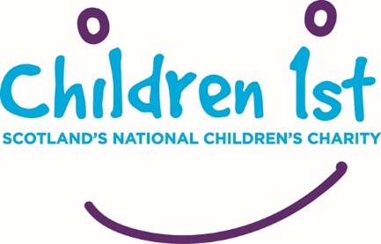
Stop to Listen Newsletter

What is Stop to Listen
Stop to Listen is a national multi-agency collaboration which aims to improve child centred responses to child sexual abuse and exploitation. This involves reviewing current practices, policies and culture to identify changes which would promote better experiences for children and young people and lead to improved long term outcomes.

What Stop to Listen is doing now
This initiative is about to enter into a pathfinder phase with 4 local authority areas: Glasgow, Renfrewshire, North Ayrshire and Perth and Kinross. The next stage of the project will mean working with local stakeholders over a series of meetings to identify what should be done differently taking into account their local context. Several services will be involved in this planning including Police, Social Work, Health, Education, Crown Office Procurators Fiscal Service, Scottish Children’s Hearing Administration Service, Voluntary Organisations and other local services.

Study visit to Croatia
The Stop to Listen Development Manager is also involved in the PROMISE Learning Exchange funded by the European Union through the Rights, Equality and Citizenship Programme (2014- 2020). This learning exchange aims promote child-friendly multi-disciplinary and interagency services supporting child victims and witnesses of violence, providing them with access to justice, avoiding re-victimization and ensuring high professional standards for recovery. The project refers to the Barnahus (Children’s House) model, and similar models such as the Children’s Advocacy Centres, embracing cooperation between all services involved with the child or young person. This is an exciting and dynamic project which will inform best practice in working with children affected by sexual abuse and exploitation.

This month included a study visit to the Child Protection Centre in Zagreb Croatia, a Health Institution which provides help and support to children with various traumatic experiences which include neglected and abused children, children at risk of abuse and their families. Every child is provided with a multidisciplinary approach by a range of professionals as appropriate including psychologists, a paediatrician, social workers, rehabilitators, social educators, nurses and a jurist (law expert). Forensic interviews are carried out and video recorded as necessary ensuring that the child does not need to appear in court to give evidence. The judge and other involved parties can watch the interview in ‘real time’ in another venue and connects to the interviewer via an ear piece allowing them to put questions to the child. The interviewer then interprets the questions for the child according to their developmental stage.

Further learning from other countries
Further study visits are planned to a children’s house in Iceland and the Sweden later this year and highlights from these visits will be included in future Stop to Listen newsletters as well as informing the pathfinder areas. Through shared commitment and collaboration Stop to Listen aims to make Scotland at the cutting edge of contemporary practice for children and young people who have experienced sexual abuse and exploitation.

For further information on Stop to Listen please contact ruth.sills@children1st.org.uk 0141 419 1162

