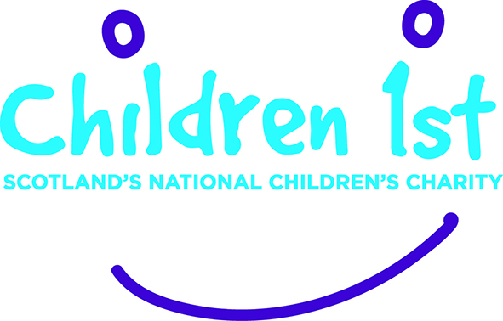

Stop to Listen Newsletter August 2016

What is Stop to Listen
Stop to Listen is a national multi-agency collaboration which aims to improve child centred responses to child sexual abuse and exploitation. This involves reviewing current practices, policies and culture to identify changes which would promote better experiences for children and young people and lead to improved long term outcomes.

Progress update
All four pathfinder areas have now identified their areas of change with some common themes emerging around staff confidence and practice. This could be at the point where a child might choose to speak out about abuse or is displaying some behaviour that raise a concern as well as children’s experience of processes like joint interviewing.

Areas are now working on their individual project plans with a view to implementing their test areas towards the end of this year.

I am also working in partnership with the NSPCC and the West of Scotland Managed Clinical Network for Child Protection to scope out trauma and recovery services in the four pathfinder areas and in the West of Scotland. We have developed a survey for services which seeks information about demand for services, referral criteria and capacity as well as range of other questions. This research will then be analysed and shared in the pathfinder areas to inform future development.

Study visit to Iceland
In June I attended the second study visit to Iceland as part of the PROMISE Learning Exchange which aims to promote the development of children’s house models across Europe. The visit took place in Reykjavik, where the first Barnahus was developed, inspiring similar ‘Barnahus’ in Nordic countries, as well as the pilot countries. The exchange meeting started with a study visit to the Barnahus, followed by training in the Barnahus procedures, which are led by the Barnahus staff with cooperation from other professionals and agencies to ensure children’s access to justice and quality care. We had presentations on the implementation of the model, forensic interviewing, working in collaboration with other agencies and trauma and recovery services.

It was hugely motivating to hear about the dedication and passion of the Barnahus staff and this stimulated a lot of discussion in the pilot countries. I am proactively sharing the learning from the PROMISE Learning Exchange as widely as possible, to seek to inspire others about the possibility of a future Barnahus in Scotland. In England the children’s house model will be piloted in Greater London and County Durham and we will watch closely to hear about the developments as they evolve.

Justice for Children Conference
The Justice for Children Group a child witness reform alliance chaired by Children 1st are delighted to welcome the Barnahus from Oslo in Norway to the Getting it Right for Child Witnesses conference on 12th October at Tulliallan Police Training College. Lord Carloway, Lord President and Michael Matheson the Cabinet Secretary for Justice will also deliver a keynote address and we will also hear from colleagues in England about developments for child witnesses in their justice system.

For further information on Stop to Listen please contact ruth.sills@children1st.org.uk 0141 419 1162

