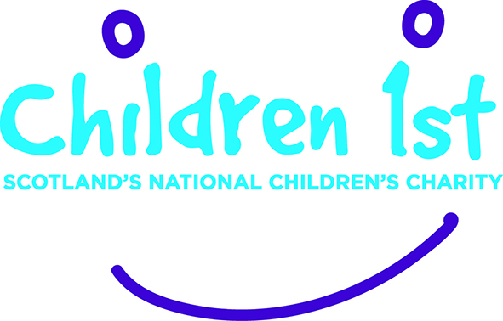

Stop to Listen Newsletter

February 2017

What is Stop to Listen
Stop to Listen is a national multi-agency collaboration which aims to improve child centred responses to child sexual abuse and exploitation. This involves reviewing current practices, policies and culture to identify changes which would promote better experiences for children and young people and lead to improved long term outcomes.

Progress update
All four pathfinders have developed their project plans and are moving towards implementation. In North Ayrshire they have undertaken a multi-agency raising awareness workshop event with another ‘whole school’ event planned in February. The first event was very successful with some creative ideas about how to promote the Stop to Listen approach in North Ayrshire. In other pathfinders plans include:

- further training for social work and education staff
- development in joint interviewing
- scrutiny of current processes and practice to ensure that responses to children and young people are child centred.

The trauma recovery scoping in partnership with the NSPCC and the West of Scotland Managed Clinical Network for Child Protection is almost complete with draft reports sent to the four areas for final comment. In further developments Stop to Listen is scoping out models of promoting healthy sexual relationships and building resilience in schools as well as embarking on a consultation with young people and young adults about their experience of responses to speaking out about sexual abuse.

PROMISE Learning Exchange
The Stop to Listen steering group continue to be involved in study visits to other European countries with children’s house models based on the Barnahus model via Anna O’Reilly Assistant Director for the East. Anna attended a trip to Sweden in November and will be joined by key Scottish Government lead official for child protection and justice on an exchange visit to Holland in March. This is a significant achievement and largely due to the influencing and policy work of Children 1st.

Following the success of the Justice for Children conference in October Anna has been involved in the joint interviewing working group of the Evidence and Procedure Review. This has offered further opportunities to consider practice from other countries and recommendations have been made about future developments in Scotland.

For further information please contact ruth.sills@children1st.org.uk 0141 419 1162

