North Ayrshire Child Protection Committee
Newsletter

December 2019 Issue 2
Merry Christmas!
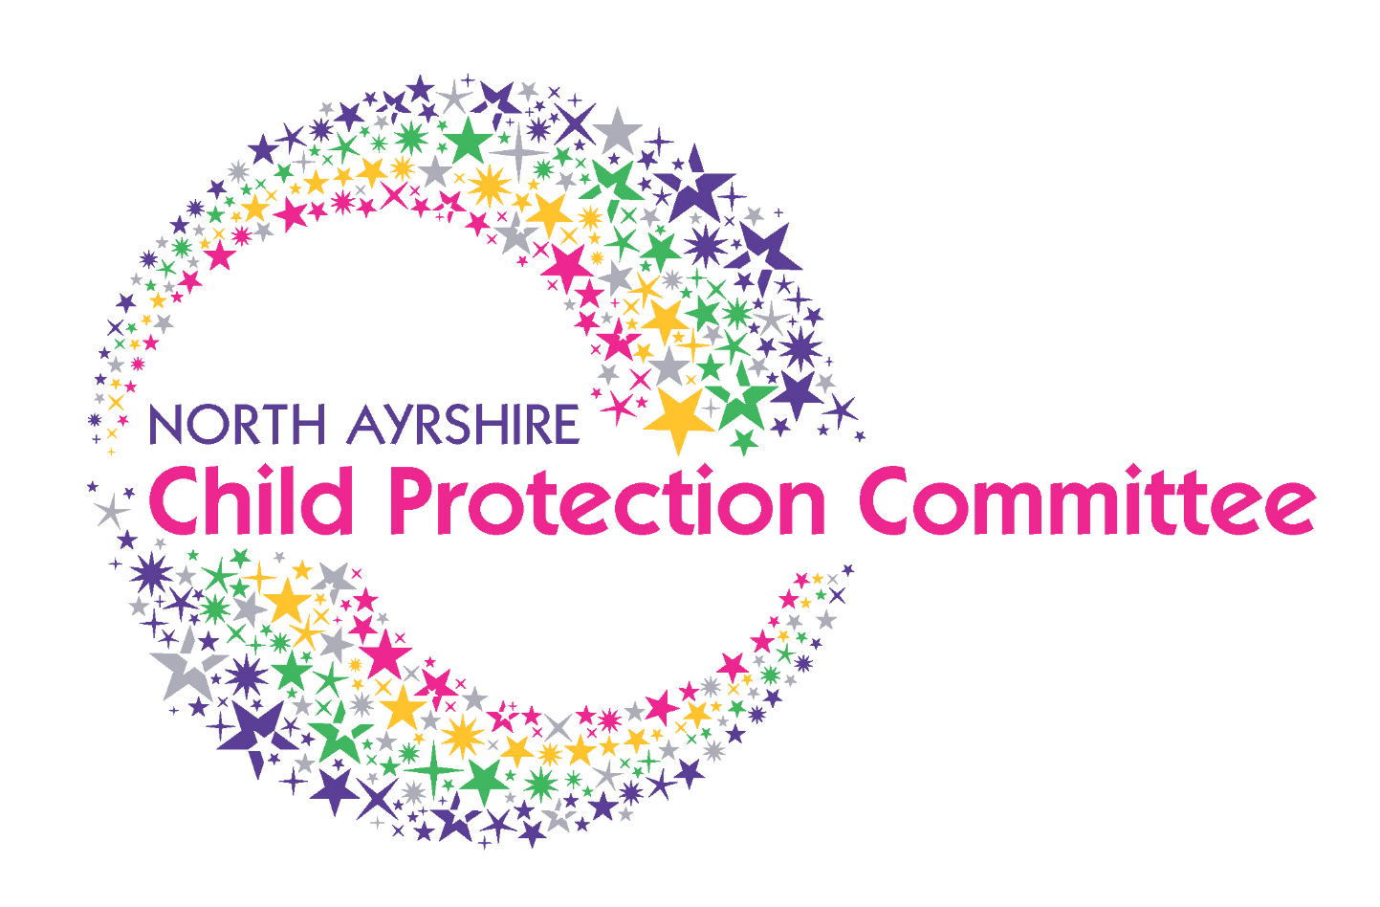

CPC Spotlight

Name: David Thomson
Job: Associate Nurse Director
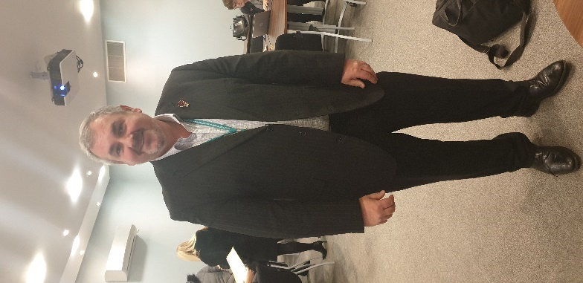
What does your job involve?

“My job is split into three main components. I am the professional nurse advisor for Mental Health, Learning Disabilities, Addictions and Child and Adolescent Mental Health Services. It’s my responsibility to ensure that care is at a high standard and ultimately ensure that professional practice is safe and effective. I am also the Lead Nurse within the North Partnership providing advice, guidance and assurances as a member of the Integrated Joint Board (IJB). I also act as the NHS Board lead for Multi-Agency Public Protection Arrangements (MAPPA). I’m responsible for the NHS Workforce Solutions referred to as the Nurse Bank and Chair several locally based groups such as Clinical Care Governance as well as National Groups such as the Mental Health Nurse Forum Scotland”.

How does Child Protection come into your role?
“Child Protection is threaded through all aspects of health care. The key aspiration for me is to make sure that all staff and others are aware and vigilant to their role and responsibility in relation to Child Protection and that they know what to do when they have concerns about a child’s wellbeing or welfare”.

What do you think is the biggest challenge for child protection within your area of work?
“What has been identified through audit and review activity is that there is a strong feeling that more staff could be referring or raising concerns (with regards to child protection). I think that staff can often have concerns but don’t feel confident in triggering a concern or referral without being sure that something is wrong and feel the concern needs to be definitive rather than taking the cautionary and protective steps that could be taken earlier. Activity is improving but we need to do more and keep building on knowledge and confidence in line with good practice and policy guidance.”

What are your current main priorities within your work?

“Safe and effective person-centred delivery of care is a key focus however I feel strongly that we need to also give the same priority in promoting staff wellbeing in a demanding and challenging environment.. Without good staff wellbeing we cannot provide a high quality of care”.

What is your favourite part of your role?

“I feel privileged to be in the job I am in and to have influence on a varied Health and Social Care Partnership landscape. Working with dedicated and enthusiastic staff is a favourite part of my job and seeing how we often have a positive impact on people’s lives. It’s also great when you can inject elements that promote joy in work”.

What is the most challenging part of your role?

“I suppose it depends what part of the job you are talking about. A big challenge at the moment is the pace and time it takes to fill posts within budget. I feel I could do more to support those delivering services directly to our communities as I believe in order to deliver the best standards of care and to provide support, we need to make sure we have a full complement of staff”. If honest I’m a nurse at heart first and foremost and learning to navigate ever changing political and strategic environments is always interesting”.

Contact details: David.Thomson3@aapct.scot.nhs.uk

Hear 4U North Ayrshire
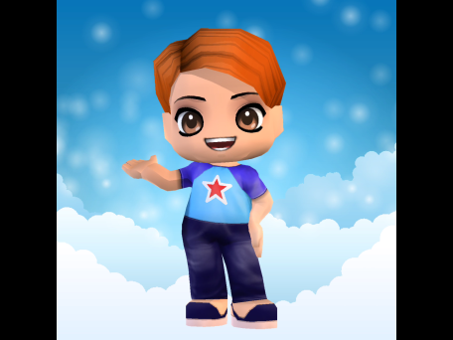
Selwyn McCausland (National Children’s Rights and Advocacy Manager) delivered a presentation on the new child and young people advocacy service within North Ayrshire: Hear 4u at the recent Child Protection Committee meeting Priority groups for this service will be children in residential / foster / kinship care and children on the Child Protection Register. Selwyn discussed the exciting use of avatars within the advocacy service. This will mean that children can create their own avatar to make sure that their voice and views are heard by families and workers at meetings that they may not necessarily feel able to attend. The service is based within Barnardos in Kilwinning, and referrals for support can either be self made or via the Health and Social Care Partnership.

Development Session

The CPC held its annual development session to review, discuss and agree business priorities for 2019/2020. We discussed our priority outcomes for children and young people and how we can ensure that we measure the impact our work is having on the lives of vulnerable children and young people in North Ayrshire. The Committee worked hard in this development session and the Lead Officer is in the process of confirming outcomes and actions for next year. The current 2019/2020 Child Protection Business Plan is available via the following link: http://childprotectionnorthayrshire.info/cpc/professionals/introduction/. There was also discussion regarding non-familial Child Protection concerns, for example child sexual exploitation, trafficking, online abuse, missing children etc, and the role of the Child Protection Committee in ensuring that children and young people are receiving the necessary supports in these circumstances. It is the role of the CPC to monitor trends and emerging risks for children and young people and to recommend practice development in response.

Don’t be scared, get it shared!

If you have concerns regarding a child, please ensure that information is shared in accordance with your agency’s child protection procedures. GDPR and the recent Scottish Government announcements with regards to GIRFEC and Named Person do not change how agencies should communicate and share information if they have concerns in relation to a child’s welfare. If you do have concerns about a child or young person and are doubting whether to share the information, share it.

CPC Training Calendar

The 2020 Child Protection Training Calendar is now online! Courses for this year include Child Protection Awareness, Child Sexual Exploitation and Trafficking, Working with Resistance, Chronology Workshop and many more! Please see http://childprotectionnorthayrshire.info/cpc/training/ for information on courses and how to book. Please note all courses are free for workers within North Ayrshire.
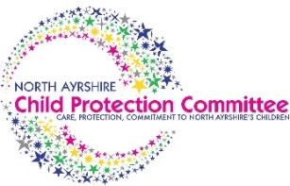 | Useful Websites & Links  Please note this is not an exhaustive list and is updated in each issue
In order to provide staff with accessible resources to meet individual needs, establishments have been directed to several links to support practice.
North Ayrshire Child Protection Committee Training Calendar | http://childprotectionnorthayrshire.info/cpc/training/
North Ayrshire Child Protection Committee Visual Diagrams | http://childprotectionnorthayrshire.info/cpc/8348-2/
North Ayrshire Child Protection Committee 2019 Business Plan | http://childprotectionnorthayrshire.info/cpc/professionals/introduction/

