October 2020: Issue 4

North Ayrshire Child Protection Committee

October 2020 – Issue 4

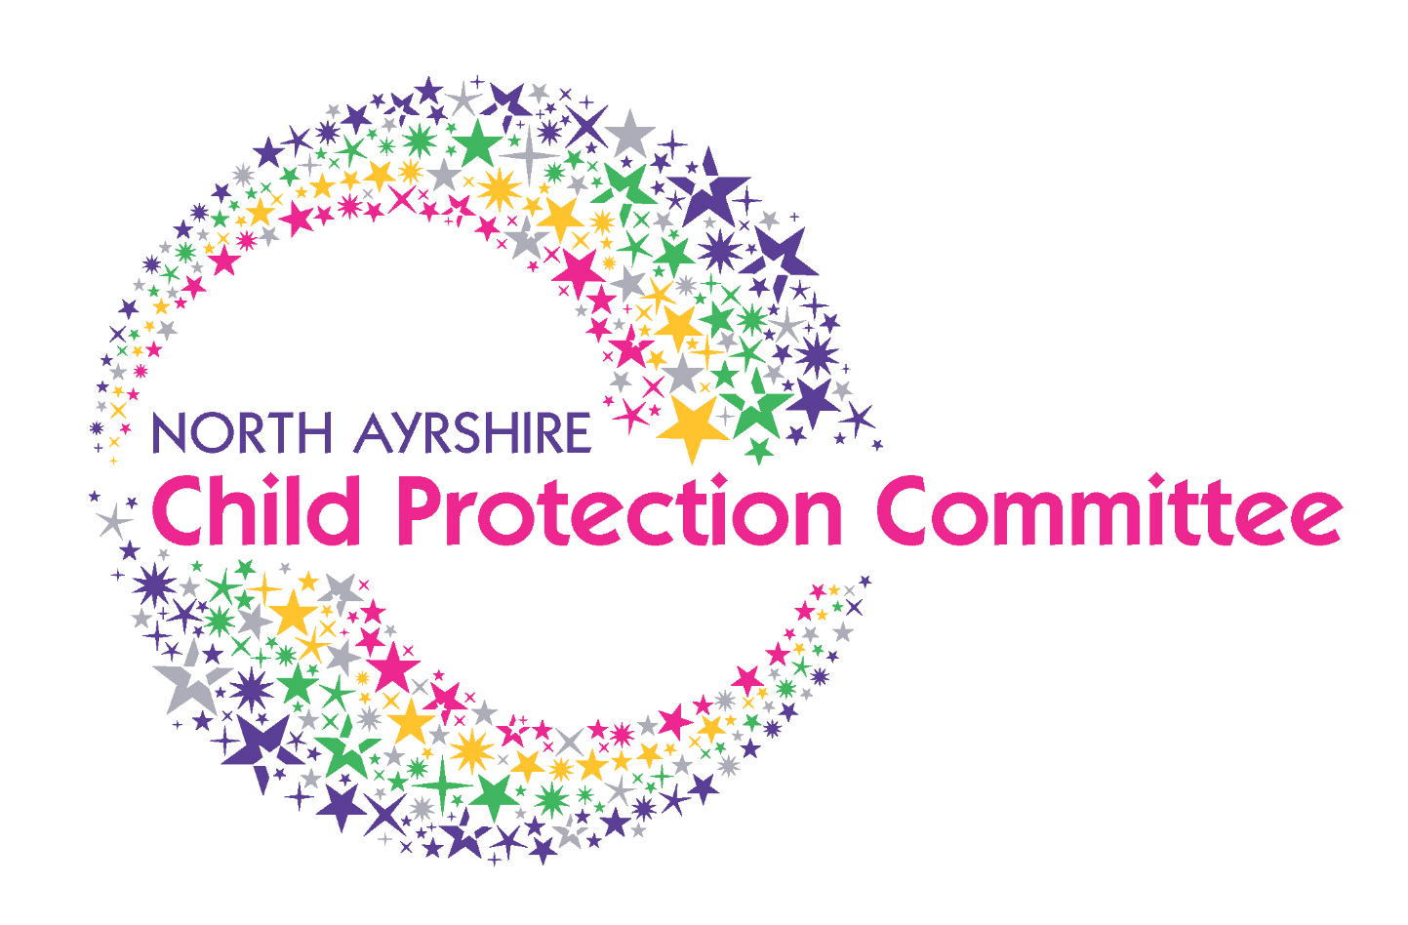

CPC Spotlight

Name: John Paterson

Job: Child Protection Committee (CPC) Independent Chair

You came into the role of CPC independent Chair at the end of March 2020, just as we were brought into lockdown due to the Covid 19 pandemic. What have been your priorities since coming into the role?

“Putting COVID to the side for a moment, it was imperative to identify as quickly as possible what the main priorities and key pieces of work were within North Ayrshire. I have been the Chair of the Renfrewshire Child Protection Committee for over three years so I did have an understanding of Child Protection generally, but Partnerships have their own ways of working so this was my main priority.

In terms of COVID, I attended Anne’s (previous Independent Chair) last committee meeting in February, a Pan Ayrshire Chairs meeting in March, then due to the pandemic, all meetings were postponed so it was a very strange time to say the least.

At the end of April, fortnightly virtual meetings began at the request of the Chief Officers, with Core CPC members giving their agency updates COVID 19 responses, the impact and changes to service delivery and identified risks, to ensure children in North Ayrshire were still being protected and kept safe during the pandemic.

These meetings were very insightful as they were coming from an operational side rather than strategic and all who attended felt they were worthwhile to see what each service / agency was doing and were able to work together / feed off each other.

Although these meetings have now been stood down, the option is there to reinstate them should there be a need to”.

What is your favourite part of your role?

“Meeting with Kirsty! (CPC Lead Officer)

Seriously though, given I have been Chair of committees since I stopped full time work, it is seeing the improvements to child protection and knowing we are making a difference to children’s lives, health, safety and well-being by examining, changing and adapting processes where required which gives the most satisfaction.

In terms of child protection in North Ayrshire during COVID, it has been extremely satisfying to be able to bring services and agencies together and to ensure processes are still in place and the enthusiasm to adapt were necessary to ensure there is no impact to child protection. It is great knowing that during these times, services are resuming as normal, albeit with COVID rules and regulations in place”.

What is the most challenging part of your role?

“Again meeting with Kirsty!

Joking aside, by and large, I feel I’m OK at chairing meetings, but is difficult taking over from Anne, who did the role for 6 years and is immensely knowledgeable with regards to child care and child protection. It’s about being able to move into the role in a way that is both comfortable for myself and all the members”.

You have been chair of the APC since April 2012, do you see opportunities for Adult Support and Protection and Child Protection to be more interlinked?

“In short, both yes and no. Since adult protection came into being in 2007, both the Chief Officer Group and public protection have become more integrated. As such, there are crossovers and similarities with both CPC and ASP, such as poverty, neglect etc. There are however operational and governance differences on a local level which we need to bear in mind, which would make it extremely challenging to have joint committees (though I am aware this is the practice in some other areas).

We can however learn from each other and be more joined up as evidenced by recent child protection cases where adults have also required intervention and support. This shows we need to interlink better and treat referrals as joint concerns”.

Covid 19

The CPC continues to adapt to the ‘new normal’. All meetings are being convened virtually and every effort is made to ensure that agencies are protecting children and young people in these challenging times. All CPC staff continue to work remotely and are available on the following mailbox at cpc@north-ayrshire.gov.uk. Please email this address if you have queries and we will get back to you as soon as we can.

The Child Protection Committee is now meeting quarterly and all sub-groups have now been re-convened. Sub-group members have been forward thinking and creative in continuing or developing pieces of work to ensure that children are protected under challenging times. We want to thank all committee members and sub-group members for their commitment and determination in getting these groups up and running again.

We are regularly uploading information in relation to Covid 19 on our website (including the latest Child Protection Guidance). Please check the following page for more information: http://childprotectionnorthayrshire.info/cpc/professionals/introduction/ and email the CPC mailbox if there is anything you would like to see on this page.

Child Protection Public Information

As pandemic restrictions continue to affect all children and families across the country, a new Scotland-wide multi-agency digital child protection campaign launched on Thursday 17 September.

As Scotland’s children settle back into the school routine and slowly begin to return to clubs and out-of-school activities, the month-long campaign aims to raise awareness that while lockdown and the pandemic has been hard going for many families and children, it’s been a lot more challenging for some families than others. Families who were struggling to cope before the pandemic may have been pushed to crisis point during lockdown, and even the most settled families will have faced new challenges during this time.

Some children and young people may have experienced trauma for the first time, and some may have experienced neglect and abuse.

This new campaign urges everyone to be alert to signs that all is not well for some children, and to take action if they’re worried that something is wrong.

Built around the message that it’s always better to say something than do nothing, the ad campaign features three digital “adverts” posted across YouTube, Facebook and Instagram, and points to a new campaign webpage on the Child Protection Scotland website.
https://www.childprotection.scot/after-lockdown/
We are on Twitter and are regularly posting videos and Tweets for sharing widely regarding these messages and in relation to other child protection information. If you have not already done so, please follow us on Twitter @NA_CPC and also follow @childprotectsco for national updates!

If you are working with communities within North Ayrshire and would like child protection resources and information, please contact us via the mailbox cpc@north-ayrshire.gov.uk.

Training
North Ayrshire Child Protection Committee is currently unable to facilitate face to face practice development due to Covid 19 restrictions. However, a combination of virtual training sessions and e-learning modules are available and can be accessed here: http://childprotectionnorthayrshire.info/cpc/training/. Modules include Child Protection Awareness, Keeping Children Safer Online and Child Sexual Exploitation.
Alison Linton, our Learning and Development Co-ordinator is also available to deliver be-spoke sessions to staff teams on child protection via Microsoft Teams. If you are interested please email cpc@north-ayrshire.gov.uk for further information.
To get a flavour of some of the courses delivered and feedback, please see the 2019 CPC Learning and Development report via the following link: http://childprotectionnorthayrshire.info/cpc/professionals/introduction/

Data

Alison Sutherland (HoS Children and Families HSCP), Stuart Singleton (Performance Officer HSCP) and Kirsty Calderwood (CPC Lead Officer) met with CELCIS (Centre for Excellence for Children’s Care and Protection) to discuss North Ayrshire’s implementation of the Minimum Dataset. The National Minimum dataset is a collection of key child protection data indicators; examples include the number of children on the Child Protection register and risk indicators present when a child is placed on the Child Protection Register. The Management Information Group (a multi-agency sub-group of the CPC) meets quarterly to analyse this data and take actions as appropriate in response to this. At the meeting, CELCIS were complimentary of North Ayrshire’s commitment to the dataset and were positive about how the data was being scrutinised and analysed. If you would like further information about the data, trends and analysis from the Minimum Dataset and how this is used, please email cpc@north-ayrshire.gov.uk.
North Ayrshire is also reporting on weekly child protection and vulnerable children and young people data to the Scottish Government in response to the Covid 19 pandemic. An online tool is available to visualise the data that is submitted from North Ayrshire and all other areas across Scotland. If you are interested please see attached link: https://public.tableau.com/profile/sg.eas.learninganalysis#!/vizhome/VulnerableChildrenandAdultProtection/Introduction

