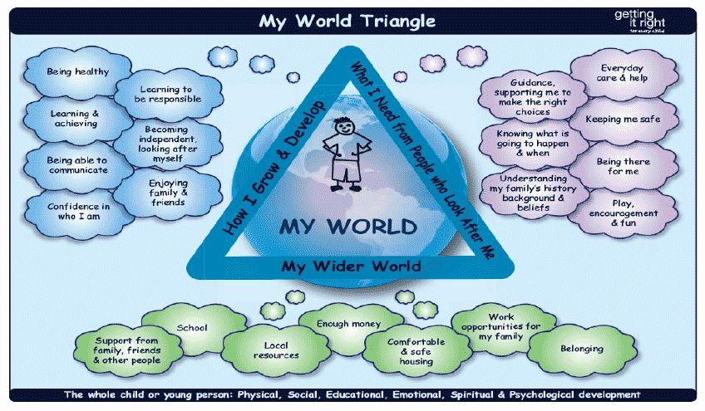
National Risk Framework for Assessment of Children and Young People
My World Triangle: Analysis of Indicators.
(Using the information gathered in pages 2-5 please provide your analysis/summary)
Risk Indicators for: | Name: |  | Identifier :
How I Grow And Develop  (Insert Indicators) | What I Need from the People Who Look after Me |  | Family and Wider World

What is the information telling me about the level of concern/risk? (Consider frequency, duration, severity, single or accumulative in nature - significance of factors in reaching a conclusion about the level of risk.)
What action is required ?

How I Grow and Develop The Child

Generic Indicators

Premature birth/low birth weight
Early prolonged separation at birth
Baby born with substance withdrawal (NAS)
Very young - highly dependent (birth - 5 years)
Cries frequently, difficult to comfort
Difficulties in feeding/toileting
Periods of separation from parent/primary caregiver
Adopted or step-child
Fostered
Child developmental delay
Child mental health difficulties
Child learning disabilities
Child behavioural difficulties
Difficult temperament
Health issues requiring ongoing medical treatment
Engaging in self-harm
Involved in substance misuse
Anti-social behaviour/relationships
Involved in offending
Evidence sexually inappropriate behaviour
Poor relationship with parents
Fearful of parent/caregiver
Outwith parental control
Child not seen by or given chance to talk to workers
Contested contact and residence issues
Repeat victim
Historical abuse of siblings by carers
Direct or indirect exposure to domestic abuse
Statutory or child protection measures in place
Poor school attendance
Young carer
English is not first language of child
More than 4 children in the family

Notes / Analysis.

What I Need from the People Who Look after Me

Generic Indicators
Parent under 21 years
Poor parenting skills
Poor understanding of child’s needs
Lack of empathy
Unrealistic expectations of child (age and stage)
Unable and/or unwilling to meet child’s needs
Poor attachment
Evidence of rejection towards the child
Lack of interest in child
Threats/requests to have the child accommodated
Child perceived as difficult and/or labelled by parent
Prioritises adult needs over child’s
Inappropriate rigid attitudes towards child
Partner is not biological parent of child
New partner -background is unknown
Parental resistance/limited engagement
Refuses workers access to child
Parents masking the reality of the situation
No shared understanding of concerns
Child’s account minimised/not believed by carer
Physical illness which impairs parenting ability
Mental illness which impairs parenting ability
Substance misuse which impairs parenting ability
Physical disability which impairs parenting ability
High stress levels such as poverty, isolation, loss
Parents parenting was poor/abusive
Low self-esteem
Poor life skills and problem solving abilities
Poor impulse control
Difficulty with communication
Lack of trust towards workers and others
History of multiple relationships
Carer continually defers to partner for response
History of domestic violence
History of community violence
History of violence /aggression towards workers
Parents in conflict over custody or residence
Inability/unwilling-ness to make use of supports
Breaches of legal orders/agreement - criminal/civil

Notes Analysis

Generic Indicators -Wider World

Family socially isolated
Absence of social supports/networks
Problems within extended family
Illness within extended family
Conflict within extended family
Substance misuse within extended family
Family - frequent changes of address
Home environment chaotic, unsafe
Concerns about sleeping arrangements
Family history of poor engagement with services
Discriminated within community victim/perpetrator
Culturally inappropriate behaviours
Neighbourhood characterised by offending/violence
Neighbourhood characterised by poverty
Housing quality poor
Lack of community services

Notes / Analysis.

