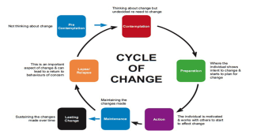
National Risk Framework for Assessment of Children and Young People
Resistance: Analysis of Indicators.
(Using the information gathered on page 2 please provide your analysis/summary)
Risk Indicators for | Name: |  | CF number:
Resistance : Child or Young Person | Resistance : People Who Look After Me |  | Resistance : My Wider World

What is the information telling me about the level of concern/risk? (Consider frequency, duration, severity, single or accumulative in nature - significance of factors in reaching a conclusion about the level of risk.)
What action is required ?

National Risk Framework for Assessment of Children and Young People
Change – Resistance Factors

Resistance Indicators Particular to the Child
(How I Grow and Develop)
Scapegoated for disclosing family problems
Fearful/unwilling to disclose anything further
Identifies with the perpetrator/strong feelings for abuser
Finds ways of coping with abuse (dissociates )
Child normalises damaging home circumstances

Resistance Indicators Particular Parent/Carer
(What I Need from the People who Look after Me)
Threatening workers (physical/verbal)
No recognition of the problems
Has a different perception of the problems/risks
Only recognises some professional concerns
No/limited/tokenistic capacity for change)
Parent/carer over-whelmed with situation
Gives different information to different workers
Says right things - not backed by behaviours/actions
Past negative relationships with professionals
No/limited aware-ness of impact of own behaviour
Lacks under-standing of what is expected of them
Actively disrupts professional plans and actions

Resistance Indicators Particular to the Child’s Family and Wider World (My Wider World)
Poor family/ community support networks
Changes service driven not driven by parent/carer
Professional splits/ disagreements
Cultural issues impact on engagement
Services not available to tackle the problem

What is the information telling me about the level of concern/risk? (Consider frequency, duration, severity, single or accumulative in nature - significance of factors in reaching a conclusion about the level of risk.)

