The General Contact Workforce

Recognising
& Responding

Those who have some direct or indirect contact with children as part of their job and are likely to come into contact with their families in doing so. This workforce member will not usually be involved in any significant work with the child or their family, but as a result of their supportive role requires the confidence, competence and skills to recognise when a child may be in need of protection and how to respond.

This is essential learning for ALL practitioners.

The Specific Contact Workforce

Assessment
& Intervention

Those within The Specific Contact Workforce will work directly with children, young people and parents/carers
on a regular basis. They will provide specific services and may be a regular contributor to the assessment process. This practitioner will see a child regularly; this may include visiting the family home. This practitioner requires a particular level of competence and confidence for the specific work they do and will also have the skills required for The General Contact Workforce.

The Intensive Contact Workforce

Intensive Support, Advanced Practice
& Management

Those with particular responsibility for protecting children and young people who require specialist knowledge to carry out
their task. This group will have fulfilled all the relevant learning and development requirements as part of the General and The Specific Contact Workforce and will also require a thorough understanding of managing / working together to protect and meet the needs of children and young people.
How to book

- Visit our Training Page of our website www.childprotectionnorthayrshire.info/cpc/training
- Select the course you would like to attend and click on the course details to complete a booking request

REMEMBER - We need your name, job title, line manager details, workplace address, contact number and email address.

Our booking policy: All those who apply for training will be advised whether they have a place or not around two weeks before any course, usually by email. If you have not received confirmation please phone and check 3-5 days before the event.

Our cancellation charge: Those unable to attend must advise us on 01294 310613 / 01294 310615 or by email at cpc@north-ayrshire.gov.uk at least 48 hours in advance.

If you cancel on time then we can fill that place from our waiting lists!

A £30 administration fee applies to all those who fail to attend without notice. This will be billed to your service.

Multi-agency Learning
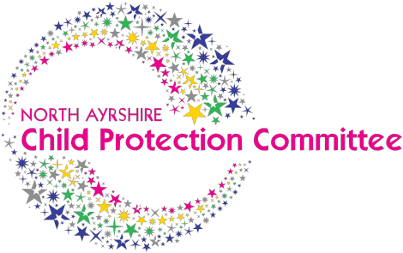

& Development
Programme
2019-2020

Promoting Good Practice in Child Protection

www.childprotectionnorthayrshire.info
www.childprotectionnorthayrshire.info www.childprotectionnorthayrshire.info
Welcome to our Child Protection Learning & Development “Quick Dates” Leaflet showing you all the days we are offering multi-agency child protection training from January 2019-December 2019

This programme, delivered by North Ayrshire Child Protection Committee, offers a wide range of learning and development opportunities for workers across the broad spectrum of child protection.

You can start your learning experience by downloading our Self Learning Pack – Understanding Child Protection, which is available on our website and provides a foundation level of information prior to progressing to ‘Child Protection Awareness’ course.

Course are delivered on a Full Day or
Half Day basis with our ‘Protecting Children in Community Groups’ session being offered as an Evening Session.

You should discuss your learning and development needs with your manager before applying to ensure suitability of course selected

Please refer to our interactive Learning & Development Programme for full course details and your eligibility to apply. To book online visit the Training Page of our website: www.childprotectionnorthayrshire.info

www.childprotectionnorthayrshire.info
www.childprotectionnorthayrshire.info www.childprotectionnorthayrshire.info www.childprotectionnorthayrshire.info

